Social media messages – Primary Care Access campaign (1 Feb – 31 March)
Please use the #Yourlocalhealthteam on all social media messages so we can monitor coverage.

Dates to post | Message Facebook/Instagram | Message Twitter | Image/animation
Ways to get in touch

Anytime | There are several you can get in touch:  -online  -on the phone  -in person  #Yourlocalhealthteam  https://www.frimleyhealthandcare.org.uk/gethelp | Your GP surgery has several ways you can get in touch:  -online  -on the phone  -in person  #Yourlocalhealthteam  https://www.frimleyhealthandcare.org.uk/gethelp | 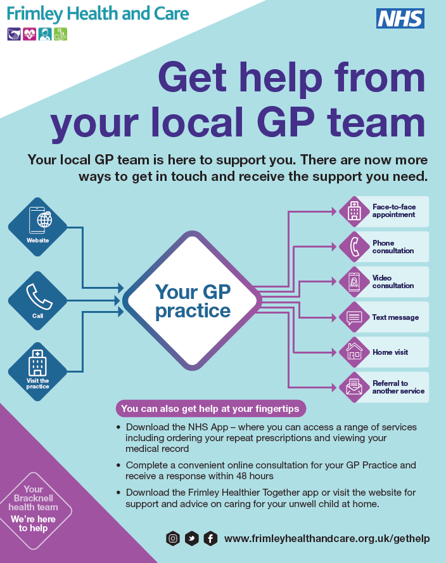
Anytime | There are three ways to get in touch:  -You can use the online form on the practice website. It’s convenient and secure and can save time.  -Call during surgery hours. Check the practice website for opening hours.  -Visit the surgery in person  #Yourlocalhealthteam  https://www.frimleyhealthandcare.org.uk/gethelp | There are three ways to get in touch:  -You can use the online form on the practice website.  -Call during surgery hours.  -Visit the surgery in person  #Yourlocalhealthteam  https://www.frimleyhealthandcare.org.uk/gethelp | Animation video : https://www.youtube.com/watch?v=XNESoTvrQWw&feature=youtu.be
Contact your practice online
Anytime | As well as phoning or visiting in person you can​:  • Complete a convenient online consultation via our website  • Download the NHS App – where you can access a range of services including ordering your repeat prescriptions and viewing your medical record  • Download the Frimley Healthier Together app or visit the website for support and advice on caring for your unwell child at home  #Yourlocalhealthteam  https://www.frimleyhealthandcare.org.uk/gethelp |  | 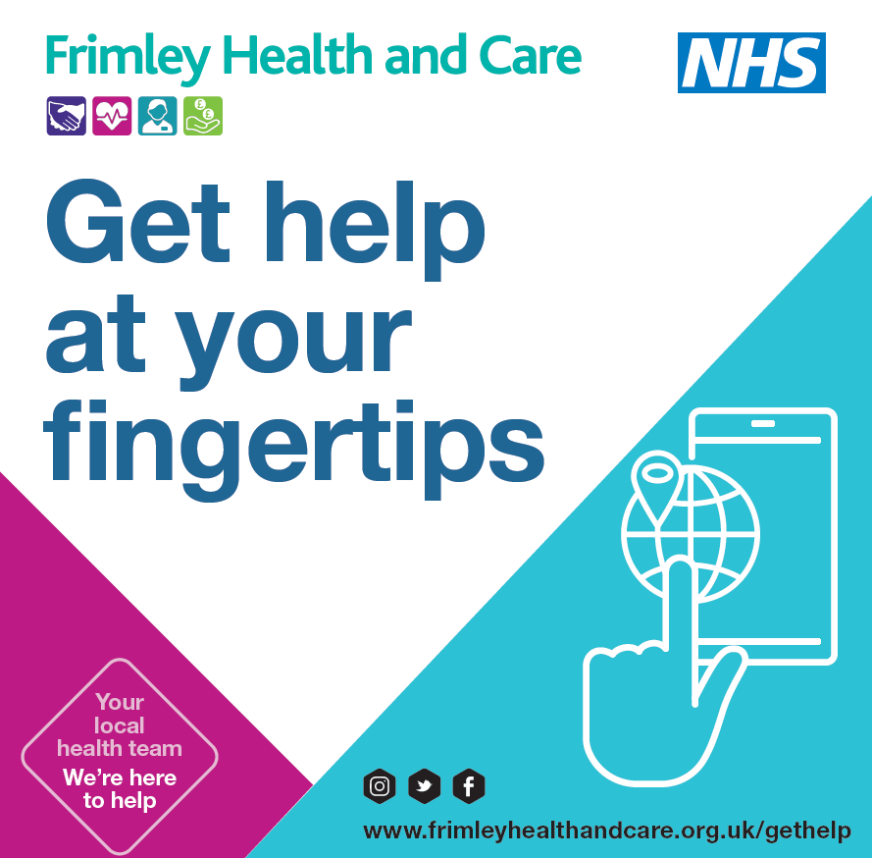
Your local health team – here to help
Anytime | Nurse Practitioners are part of the healthcare team. Highly trained and many with specialisms they are there to help you with your need and will refer on to other members of the healthcare team if needed.  #Yourlocalhealthteam  https://www.frimleyhealthandcare.org.uk/gethelp | Nurse Practitioners are part of the healthcare team. Highly trained and many with specialisms they are there to help you with your need and will refer on to other members of the healthcare team if needed.  #Yourlocalhealthteam  https://www.frimleyhealthandcare.org.uk/gethelp | Video: https://youtu.be/8_Dr75er_0c
Anytime | Rachel, a Nurse in general practice, is just one of the many experts providing the health and care support you need.  Your local GP practice is made up of a team of experts.  You may be supported by a nurse, a GP, or another colleague when you contact us depending on who has the best expertise to help you.  #Yourlocalhealthteam  https://www.frimleyhealthandcare.org.uk/gethelp | Rachel, a Nurse in general practice, is just one of the many experts providing the health and care support you need.  #Yourlocalhealthteam  https://www.frimleyhealthandcare.org.uk/gethelp | 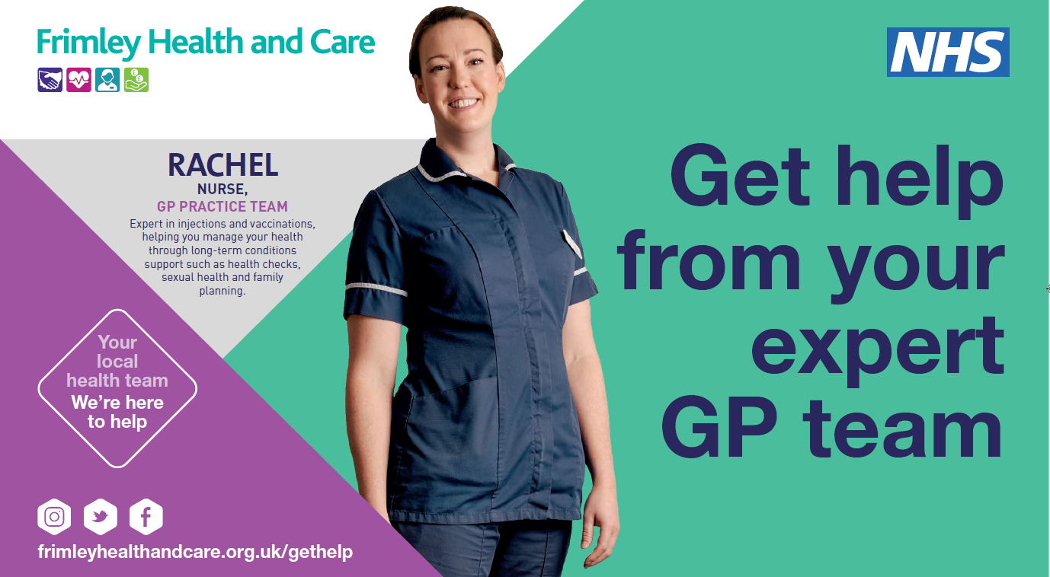
Anytime | If you’re taking one or more prescription medicines, it’s important you’re confident in what you’re doing and why. That’s where the practice’s clinical pharmacist can help.  #Yourlocalhealthteam  https://www.frimleyhealthandcare.org.uk/gethelp | If you’re taking one or more prescription medicines, it’s important you’re confident in what you’re doing and why. That’s where the practice’s clinical pharmacist can help.  #Yourlocalhealthteam  https://www.frimleyhealthandcare.org.uk/gethelp | Video: https://youtu.be/pn9USdPhrx4
Anytime | Amarpreet, a Clinical Pharmacist in general practice, is just one of the many experts providing the health and care support you need.  Your local GP practice is made up of a team of experts.  You may be supported by a clinical pharmacist, a GP or another colleague when you contact the surgery depending on who has the best expertise to help you.  #Yourlocalhealthteam  https://www.frimleyhealthandcare.org.uk/gethelp | Amarpreet, a Clinical Pharmacist in general practice, is just one of the many experts providing the health and care support you need.  #Yourlocalhealthteam  https://www.frimleyhealthandcare.org.uk/gethelp | 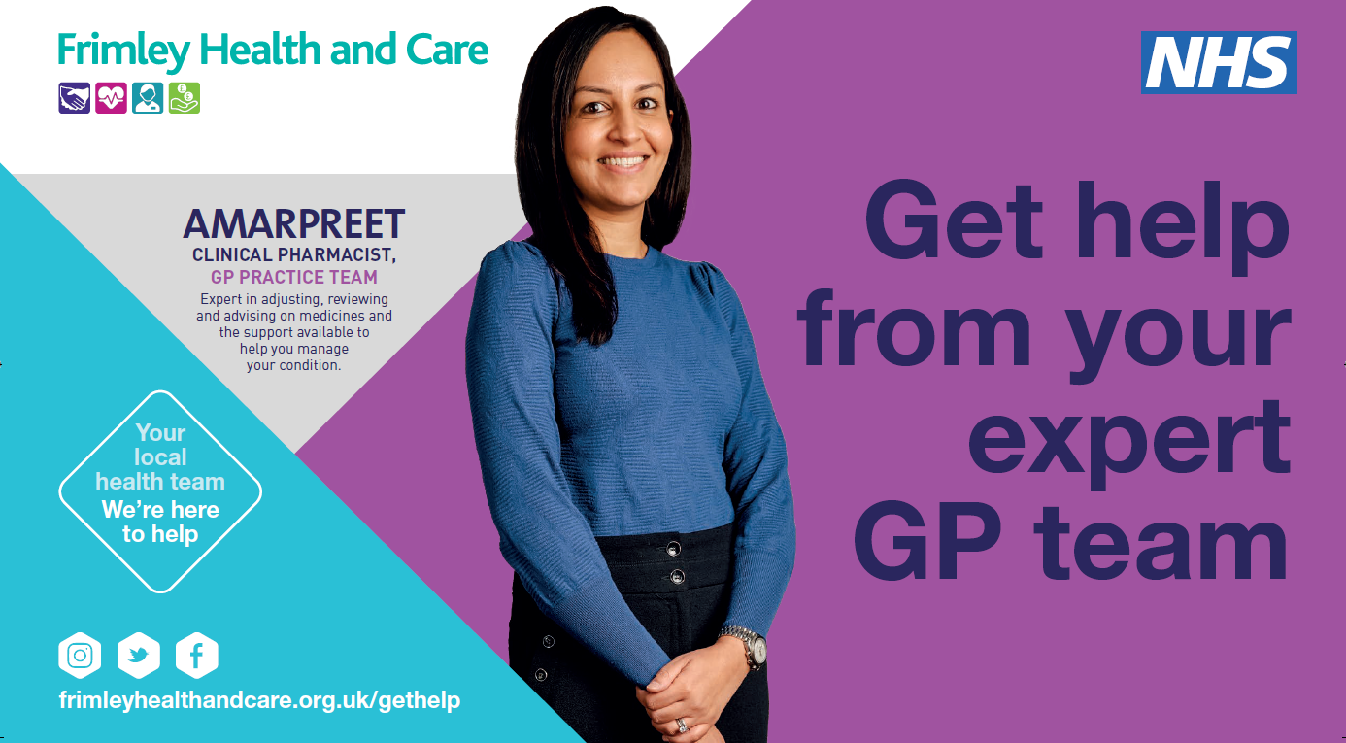
 | For many people, medication is an important tool in managing health & wellbeing. If you’re unsure about what you’re taking, ask to speak to the clinical pharmacist and make sure you know your medications.  #Yourlocalhealthteam  https://www.frimleyhealthandcare.org.uk/gethelp | For many people, medication is an important tool in managing health & wellbeing. If you’re unsure about what you’re taking, ask to speak to the clinical pharmacist and make sure you know your medications.  #Yourlocalhealthteam  https://www.frimleyhealthandcare.org.uk/gethelp | Animation : https://youtu.be/BmP5XcCz_vg
 | When you contact the surgery, you may be asked questions by the care navigator to ensure you are able to get the care you need.  #Yourlocalhealthteam  https://www.frimleyhealthandcare.org.uk/gethelp | When you contact the surgery, you may be asked questions by the care navigator to ensure you are able to get the care you need.  #Yourlocalhealthteam  https://www.frimleyhealthandcare.org.uk/gethelp | Animation : https://youtu.be/SDYHDYL5HCk
 | Huma, a Care Navigator in general practice, is just one of the many experts co-ordinating the health and care support you need.  The practice care navigator may signpost you to a GP, nurse or other colleague depending on who has the best expertise to help you.  There are now more ways to get in touch and receive the support you need.  #Yourlocalhealthteam  https://www.frimleyhealthandcare.org.uk/gethelp | Huma, a Care Navigator in general practice, is just one of the many experts co-ordinating the health and care support you need.  The practice care navigator may signpost you to a GP, nurse or other colleague depending on who has the best expertise to help you.  #Yourlocalhealthteam  https://www.frimleyhealthandcare.org.uk/gethelp | 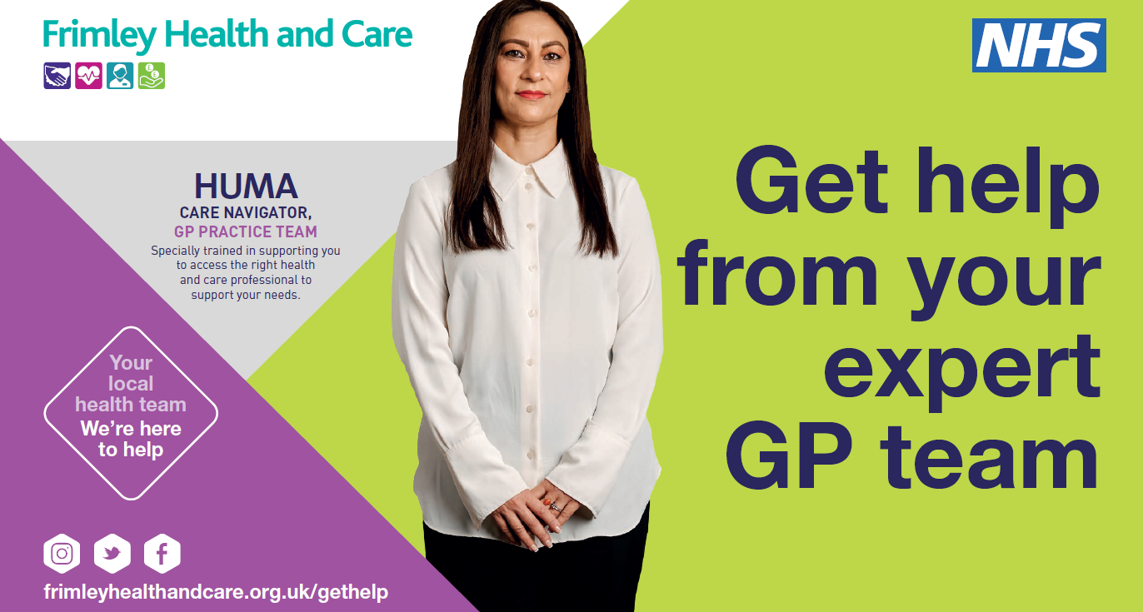
 | Did you know if you’re feeling unwell, you don’t necessarily need to see a doctor.  Your local GP practice is made up of a team of experts.  You may be supported by a GP, nurse or another colleague when you contact your surgery depending on who has the best expertise to help you.  #Yourlocalhealthteam  www.frimleyhealthandcare.org.uk/gethelp | Did you know if you’re feeling unwell, you don’t necessarily need to see a doctor.  Your local GP practice is made up of a team of experts.  #Yourlocalhealthteam  www.frimleyhealthandcare.org.uk/gethelp | Video: https://youtu.be/OM0g8QYpyd8
 | Bharan, a GP in general practice, is just one of the many experts providing the health and care support you need.  Your local GP practice is made up of a team of experts.  You may be supported by a GP, nurse or another colleague when you contact your surgery depending on who has the best expertise to help you.  There are now more ways to get in touch and receive the support you need.  #Yourlocalhealthteam  www.frimleyhealthandcare.org.uk/gethelp | Bharan, a GP in general practice, is just one of the many experts providing the health and care support you need.  Your local GP practice is made up of a team of experts.  #Yourlocalhealthteam  www.frimleyhealthandcare.org.uk/gethelp | 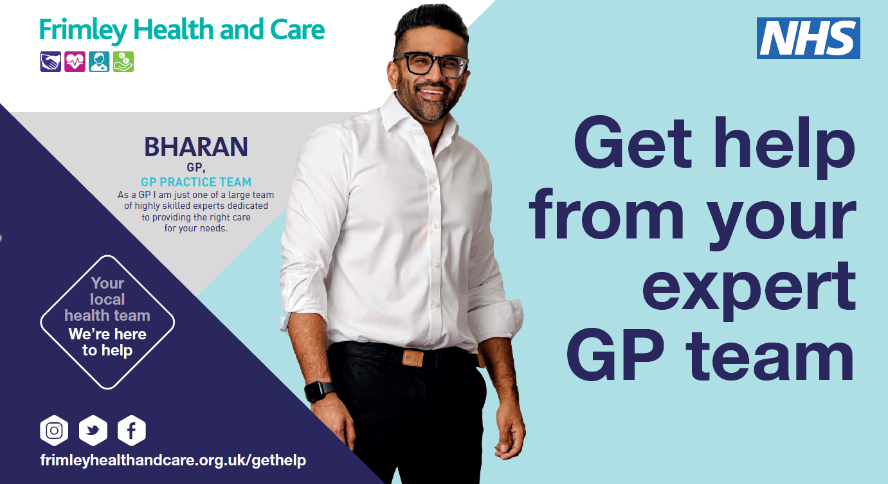
Be clear on your need, General Practice seeing more people than before and respect the team
Anytime | There are three ways to get in touch with your #yourlocalhealthteam, but no matter which route you choose, there are some important things to remember. Dr Sachdev and Dr Payne explain more.  #Yourlocalhealthteam  www.frimleyhealthandcare.org.uk/gethelp | There are three ways to get in touch with your #yourlocalhealthteam, but no matter which route you choose, there are some important things to remember. Dr Sachdev and Dr Payne explain more.  #Yourlocalhealthteam  www.frimleyhealthandcare.org.uk/gethelp | Video: https://youtu.be/-TDFa8rPF48
Anytime | #Yourlocalhealthteam team are working hard to support you and others with your healthcare issue but to do that well they need your help. Please listen to a message from Dr Doolub.  #Yourlocalhealthteam  www.frimleyhealthandcare.org.uk/gethelp | #Yourlocalhealthteam team are working hard to support you and others with your healthcare issue but to do that well they need your help. Please listen to a message from Dr Doolub.  #Yourlocalhealthteam  www.frimleyhealthandcare.org.uk/gethelp | Video: https://youtu.be/zydOSqIncMs
Anytime | We know being asked to wait can be frustrating, but your local healthcare team are working hard to ensure you see the right person. Please listen to a message from Dr Thomas.  #Yourlocalhealthteam  www.frimleyhealthandcare.org.uk/gethelp | We know being asked to wait can be frustrating, but your local healthcare team are working hard to ensure you see the right person. Please listen to a message from Dr Thomas.  #Yourlocalhealthteam  www.frimleyhealthandcare.org.uk/gethelp | Video: https://youtu.be/GbhIq2L0rIU

