Children and Young Person Mental Health campaign
Audience | Channel | Content/Messages | Link | Visual
Parents of children | General | It can be difficult to know if there is something upsetting a child or young person.  It might be time to get professional help if there is a change in a child’s behaviour that lasts for a long time or are significantly affecting them.  NHS Frimley has a range of local NHS and voluntary support services available for children and young people to support their mental health and emotional wellbeing.  Support is available from a range of children mental health specialists, and includes face-to-face and virtual sessions, advice via text and phone lines.  Children and young people in crisis can access 24/7 phone lines, to support situations where they feel they need urgent help.  Hashtag #itsoktoaskforhelp  Signpost to Frimley Healthier Together mental health pages – support and self-care page and local mental health support services | https://frimley-healthiertogether.nhs.uk/mental-health/your-local-mental-health-resource
Parents of children | Facebook | It can be difficult to know if there is something upsetting a child or young person. Ask yourself, is your child struggling?  Here are some tips to spot when something’s wrong:  - significant changes in behaviour  - ongoing difficulty sleeping  - withdrawing from social situations  - not wanting to do things they usually like  - self-harm or neglecting themselves.  If you're worried about a child or need advice and support, please visit the Frimley Healthier Together website for advice and details of local support services.  #itsoktoaskforhelp | Your Local Mental Health Resources: Frimley HealthierTogether (frimley-healthiertogether.nhs.uk) | 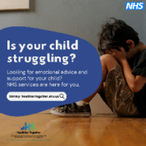  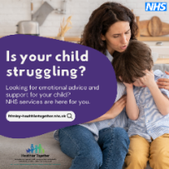  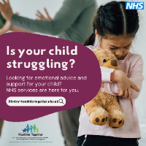
Parents of children | Twitter | Is your child struggling?  Support is available from a range of children #mentalhealth specialists including:  🧑‍🤝‍🧑face-to-face support  💻online advice  📱via text  📞by phone  Visit https://frimley-healthiertogether.nhs.uk/mental-health to find out more.  #itsoktoaskforhelp |  | 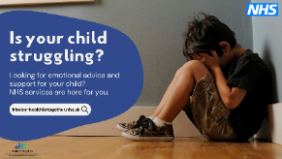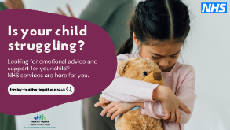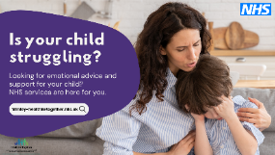
Parents of children | Instagram | We are encouraging children and parents to take the time to talk to one another about their mental health. It might be time to get professional help if there is a change in a child’s behaviour that lasts for a long time or is significantly affecting them #itsoktoaskforhelp |  | 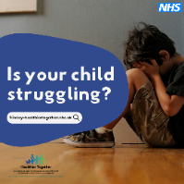  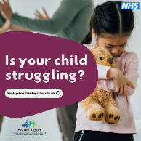  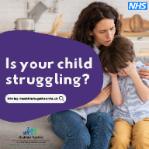
Audience | Channel | Content/Messages | Link | Visual
Young people | General messages | Feeling down, anxious, worried or need some help to work through your feelings? There is support available. It’s ok to ask for help.  Support is available from a range of young people mental health specialists, and includes face-to-face and virtual sessions, advice via text and phone lines.  NHS Frimley has a range of local NHS and voluntary support services available for young people to support their mental health and emotional wellbeing.  If you feel you are in crisis there are 24/7 phone lines dedicated to young people who can help.  Hashtag #itsoktoaskforhelp  Call to action: Signpost to Frimley Healthier Together mental health pages – support and self-care page or Frimley Healthier Together local mental health support services page. | https://frimley-healthiertogether.nhs.uk/mental-health  https://frimley-healthiertogether.nhs.uk/mental-health/your-local-mental-health-resource | 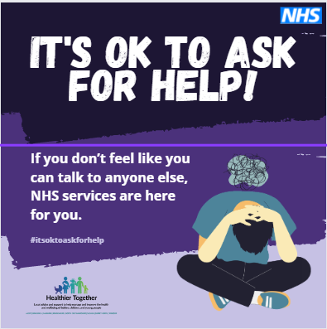  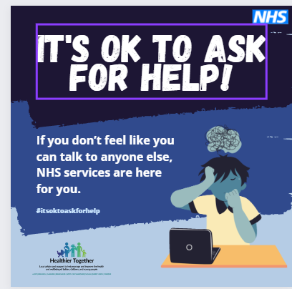  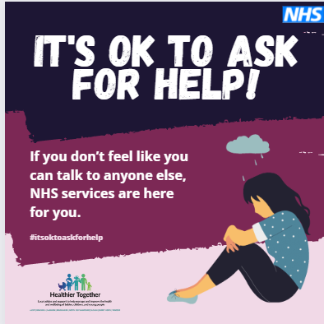
 | Instagram | Are you feeling down, anxious, or worried? It’s ok to ask for help! If you are in crisis or need some help to work through your feelings, there is support available. Visit the Frimley Healthier Together website to find the right support for you |  | 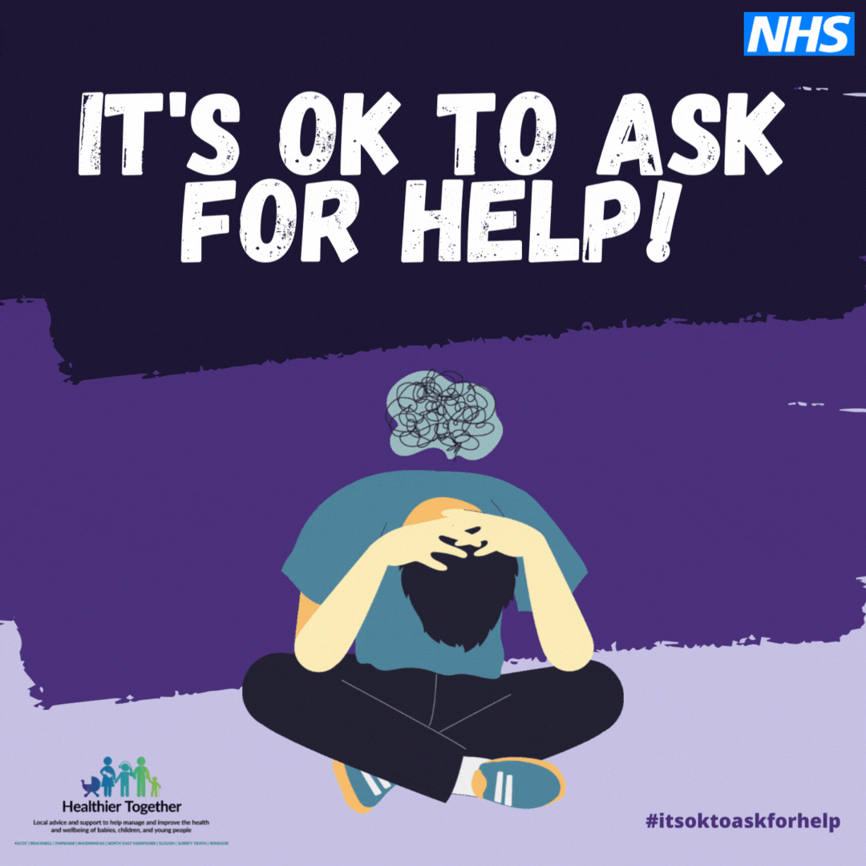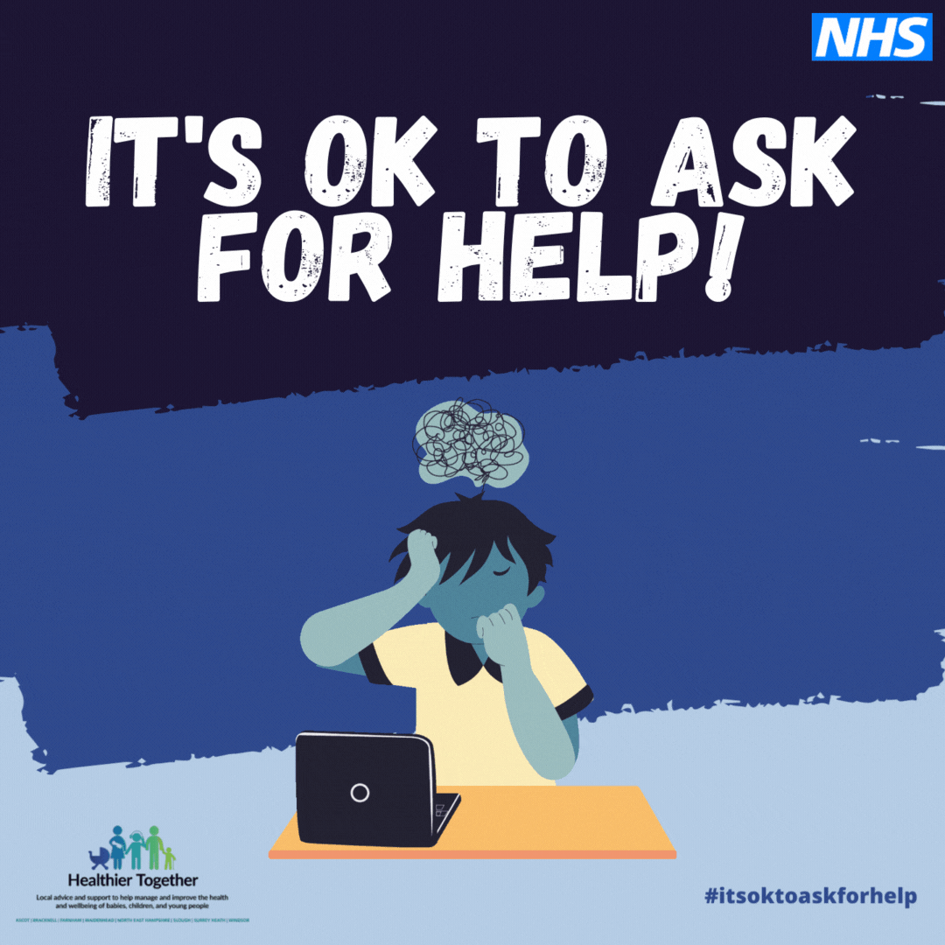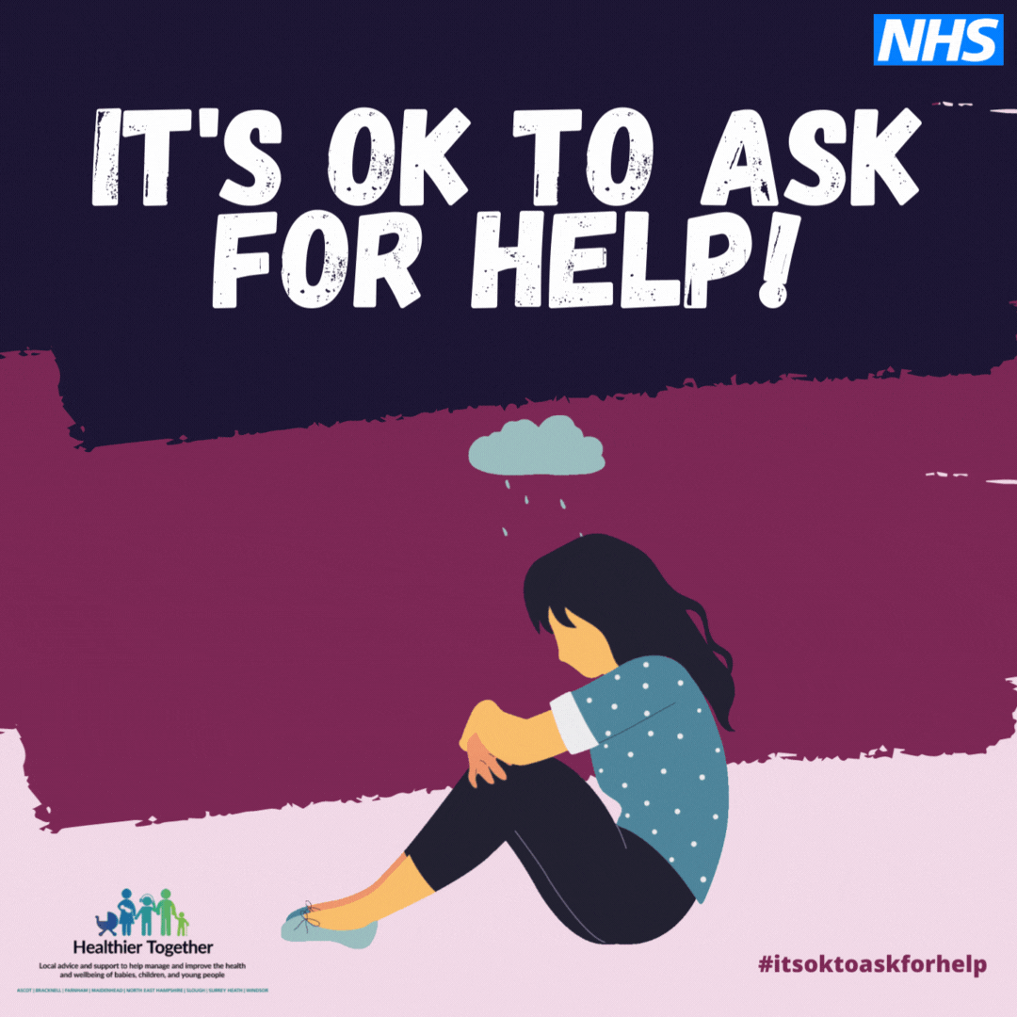
 | Twitter | Are you feeling down, anxious, or worried? Don’t struggle alone,#itsoktoaskforhelp! Support is available from #youngpeople #mentalhealth specialists including:  🧑‍🤝‍🧑face to face support  💻online advice  📱via text  📞by phone  Visit https://frimley-healthiertogether.nhs.uk/mental-health |  | 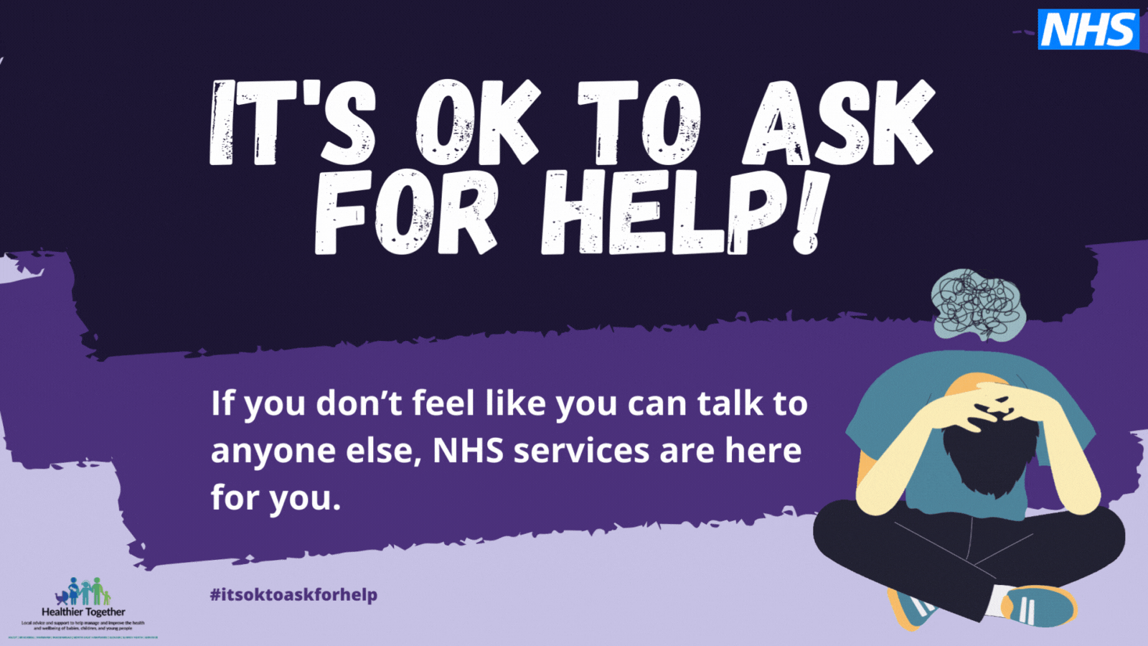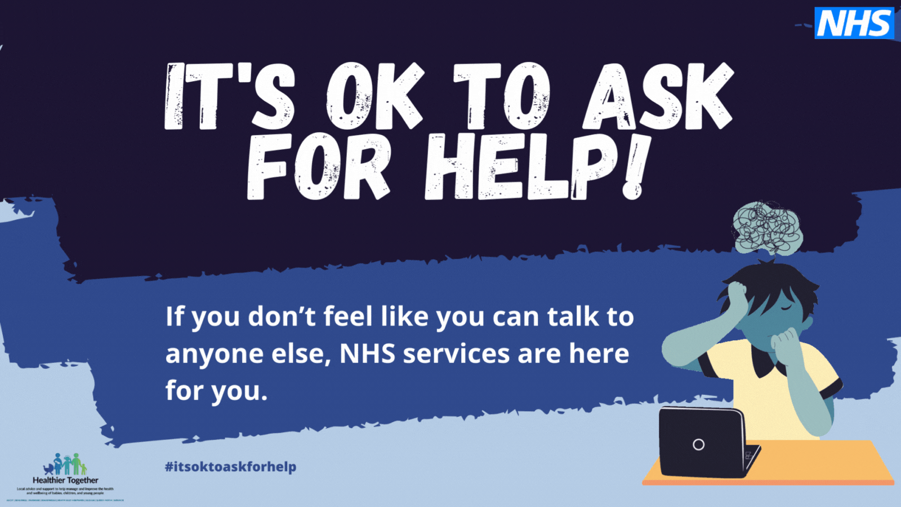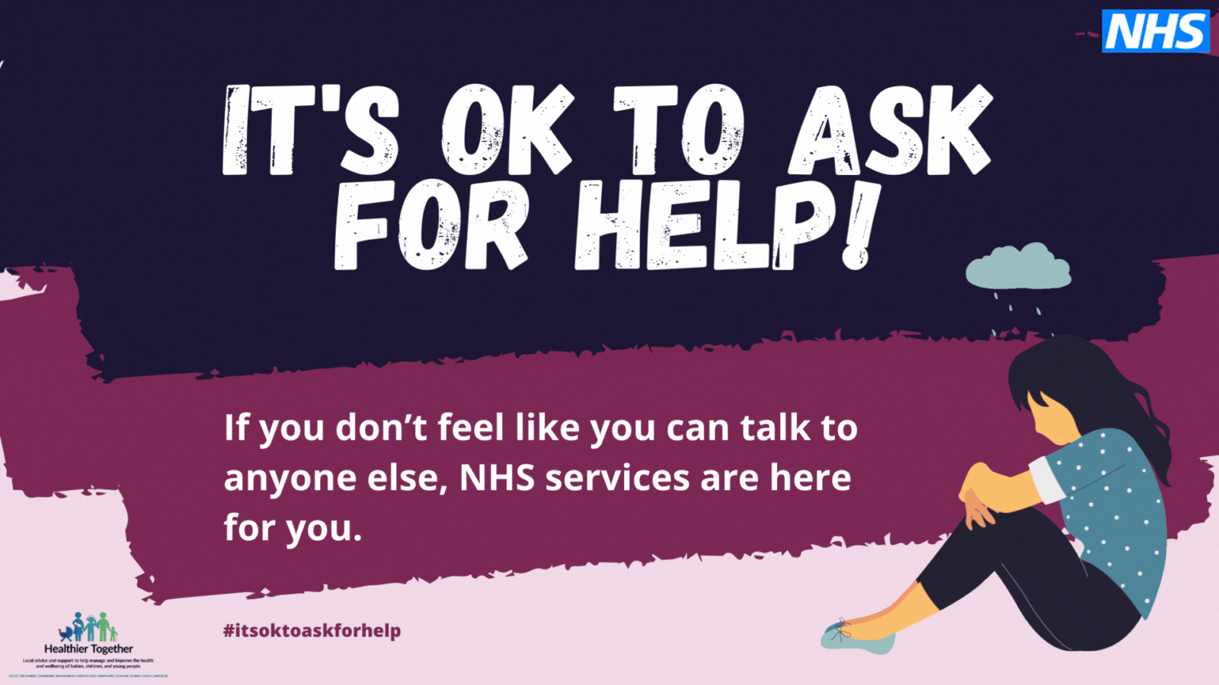
Audience | Channel | Content/Messages | Link | Visual
Young people | Facebook/  Instagram | Reel |  | 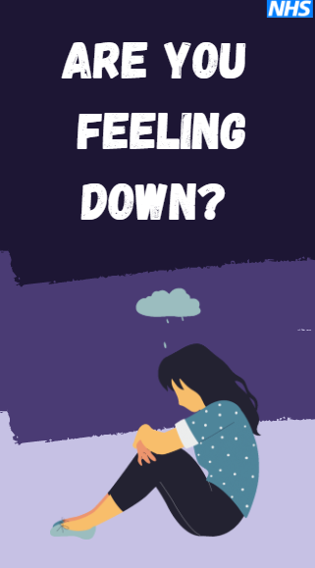
Young people | Facebook/  Instagram | Story x 2 options |  | 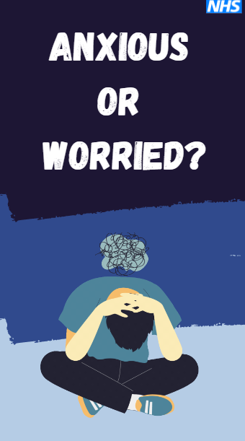
Parents of children | Facebook/  Instagram | Reel |  | 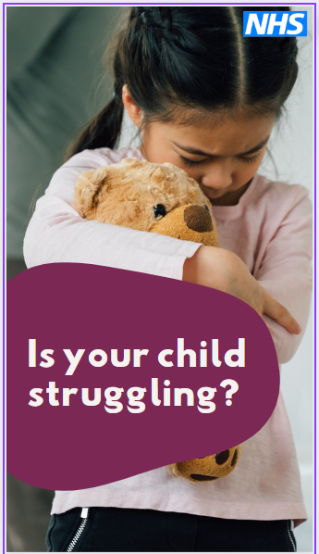
Parents of children | Facebook/  Instagram | Story |  | 