Channel | Caption | Image
Facebook & Instagram | Results day is just around the corner for many students across the UK and it can be a very stressful time.  If you are worried about how your child is coping with the anticipation of their exam results, visit https://frimley-healthiertogether.nhs.uk/mental-health/your-local-mental-health-resource for services that can support them.  #ItsOkToAskForHelp #StayWellThisSummer | 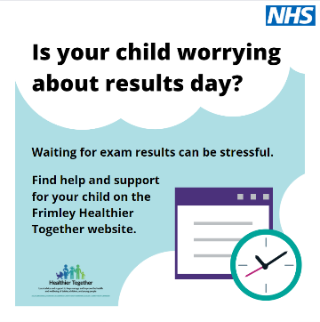
Twitter | If you are worried about how your child is coping with the anticipation of their exam results, visit https://frimley-healthiertogether.nhs.uk/mental-health/your-local-mental-health-resource for services that can support them.  #ItsOkToAskForHelp #StayWellThisSummer | 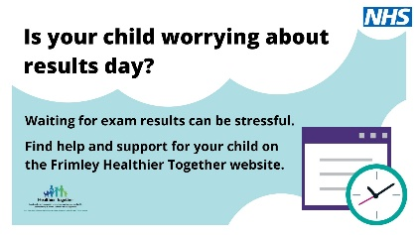
Facebook & Instagram | It is completely normal to be stressed when waiting for exams, signs of stress can include:  - Changes in appetite or sleeping patterns  - Low mood  - Feeling irritable, restless or tense  - Withdrawing from daily activities  - Having difficulty breathing  - Feeling unwell more often  If you are showing symptoms, visit https://frimley-healthiertogether.nhs.uk/health-for-young-people/growing/exam-pressure to find ways to manage your stress levels and mental wellbeing.  #ItsOkToAskForHelp #StayWellThisSummer | 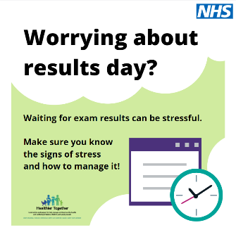
Twitter | It is completely normal to be stressed when waiting for exams, make sure you know the signs. Visit https://frimley-healthiertogether.nhs.uk/health-for-young-people/growing/exam-pressure for more information and ways to help manage your stress levels.  #ItsOkToAskForHelp #StayWellThisSummer | 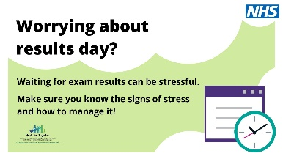
Facebook & Instagram | Worrying about your results, future plans or even how to celebrate your achievement can really start to impact your emotions and wellbeing day-to-day.  Try some relaxation techniques to help you relax and manage your stress levels.  For support and tips on exam results day visit https://frimley-healthiertogether.nhs.uk/health-for-young-people/growing/exam-pressure  #ItsOkToAskForHelp #StayWellThisSummer | 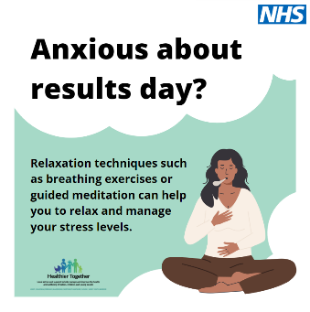
Twitter | Worrying about results day can really start to impact your emotions and wellbeing day-to-day. Try some relaxation techniques to help you relax and manage your stress levels.  https://frimley-healthiertogether.nhs.uk/health-for-young-people/growing/exam-pressure)  #ItsOkToAskForHelp #StayWellThisSummer | 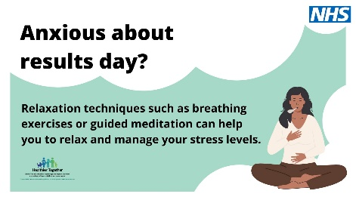
Facebook & Instagram | Results day is just around the corner for many students across the UK. Whether you’re waiting for A-level, GCSE or SQA results, you may be feeling apprehensive, and tense at the moment.  Try different techniques like listening to music or reading a book to help you look after your mental wellbeing during this stressful period.  For support and tips on exam results day visit https://frimley-healthiertogether.nhs.uk/health-for-young-people/growing/exam-pressure  #ItsOkToAskForHelp #StayWellThisSummer | 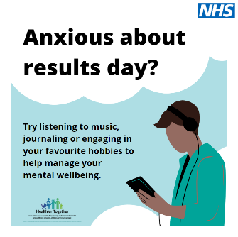
Twitter | Try different techniques like listening to music or reading a book to help you look after your mental wellbeing as we approach exam results day.  For support and tips during this stressful period, visit https://frimley-healthiertogether.nhs.uk/health-for-young-people/growing/exam-pressure  #ItsOkToAskForHelp #StayWellThisSummer | 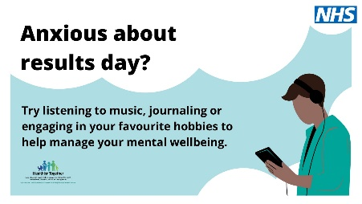
Facebook & Instagram | Waiting for results day can be extremely stressful. That’s why it’s important to look after your mental wellbeing. Try to keep active and spend some time outdoors in fresh air, they are both extremely beneficial for your mental health.  For support and tips on Exam Results day visit https://frimley-healthiertogether.nhs.uk/health-for-young-people/growing/exam-pressure  #ItsOkToAskForHelp #StayWellThisSummer | 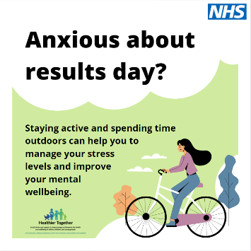
Twitter | Waiting for results day can be extremely stressful. Keeping active and spending time outdoors in fresh air are both extremely beneficial for your mental health.  For support and tips on Exam Results day visit https://frimley-healthiertogether.nhs.uk/health-for-young-people/growing/exam-pressure  #ItsOkToAskForHelp #StayWellThisSummer | 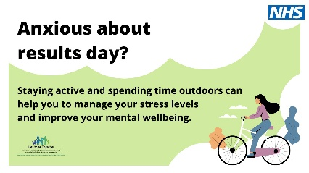
Facebook & Instagram | Is your child upset with their A-level results? Worrying about future plans?  If you are worried about how your child is coping with the news, please visit https://frimley-healthiertogether.nhs.uk/mental-health/your-local-mental-health-resource to find local services which can help and support them.  #ItsOkToAskForHelp #StayWellThisSummer | 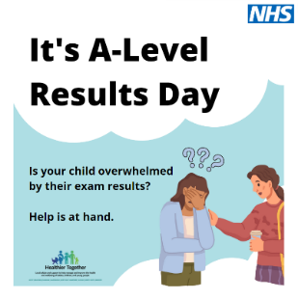
Twitter | If you are worried about how your child is coping with news of their results, please visit https://frimley-healthiertogether.nhs.uk/mental-health/your-local-mental-health-resource to find local services which can help and support them.  #ItsOkToAskForHelp #StayWellThisSummer | 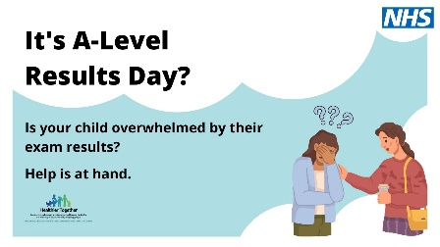
Facebook & Instagram | GCSE results not what they wanted?  If you are worried about how your child is coping with the news, please visit https://frimley-healthiertogether.nhs.uk/mental-health/your-local-mental-health-resource to find local services which can help and support them.  #ItsOkToAskForHelp #StayWellThisSummer | 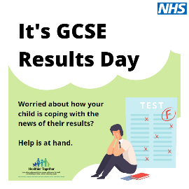
Twitter | If you are worried about how your child is coping with their GCSE results, please visit https://frimley-healthiertogether.nhs.uk/mental-health/your-local-mental-health-resource to find local services which can help and support them.  #ItsOkToAskForHelp #StayWellThisSummer | 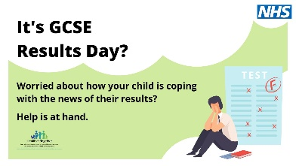
Facebook & Instagram | Exam results day can be overwhelming, there can be several different scenarios to consider.  If you are worried about how your child is coping please visit https://frimley-healthiertogether.nhs.uk/mental-health/your-local-mental-health-resourceto find local services which can help and support them.  #ItsOkToAskForHelp #StayWellThisSummer | 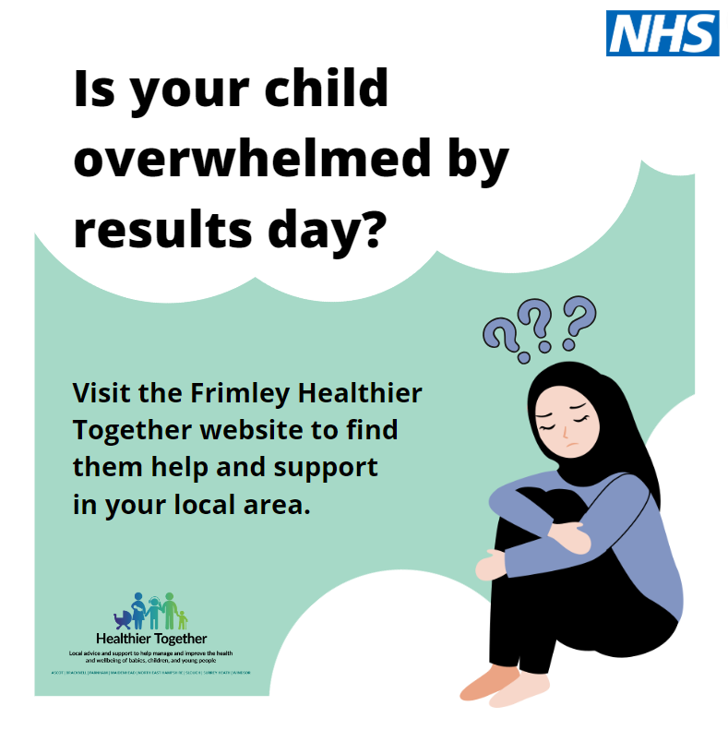
Twitter | Exam results day can be overwhelming, there can be several different scenarios to consider.  If you are worried about how your child is coping please visit https://frimley-healthiertogether.nhs.uk/mental-health/your-local-mental-health-resource for local services which can help and support them.  #ItsOkToAskForHelp #StayWellThisSummer | 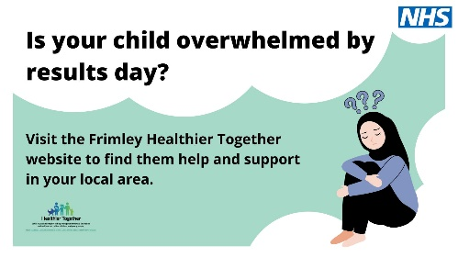
Facebook & Instagram | Is your child overwhelmed by their results?  If you are worried about how your child is coping please visit https://frimley-healthiertogether.nhs.uk/mental-health/your-local-mental-health-resource to find local services which can help and support them.  #ItsOkToAskForHelp #StayWellThisSummer | 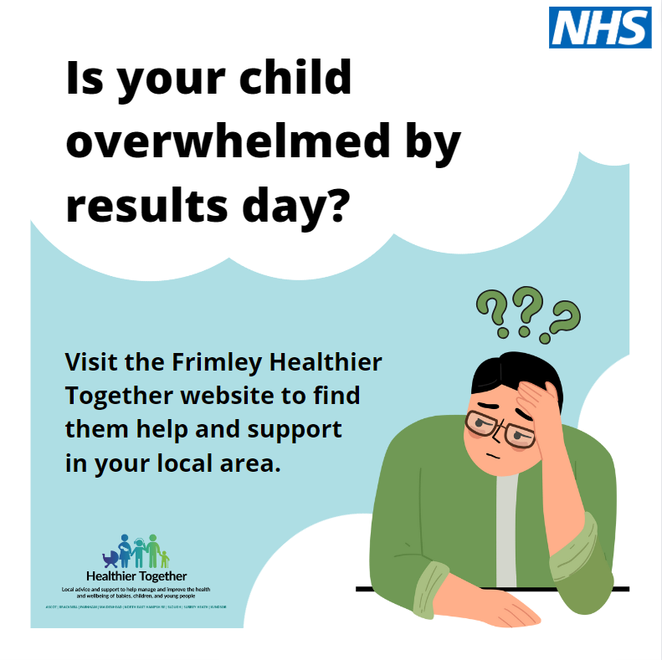
Twitter | Is your child overwhelmed by their results?  If you are worried about how your child is coping please visit https://frimley-healthiertogether.nhs.uk/mental-health/your-local-mental-health-resource to find local services which can help and support them.  #ItsOkToAskForHelp #StayWellThisSummer | 