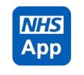
Highlighting the benefits of the NHS App to your patients this winter
The NHS App promotional toolkit is designed to help you tell your patients about the NHS App. The information and links below will help them understand the benefits, how to download and how to set up the App.
Please note the NHS App is undergoing some changes as part of a redesign but all services will still be available, however there may be elements which will be accessed slightly differently, and updated materials will be available as soon as possible to reflect these changes. Use the following link to check back for new resources, to access web banners and additional imagery.
Visit Tell your patients about the NHS App - NHS Digital
Further details for practices can be found at - NHS App guidance for GP practices - NHS Digital
Below you will find examples of:
- Newsletter/Website copy
- Text Messages
- Social Media
In addition to the information below, you can download a film produced by NHS England and the patient leaflets listed below from our campaigns resource page. List available:
- Do more with the NHS App A5
- NHS App quick start guide A5
- NHS App Repeat Prescriptions A5
And these will cover the subjects:
- Download the NHS App
- What you can do with the NHS App
- Receiving messages via the NHS App
- Ordering your repeat prescriptions with the NHS App
- Viewing your GP health record with the NHS App
Method | Message  Download and do more with the NHS App | Image
Website / Newsletter copy | Option 1  Try the NHS App  If you’re a patient at our practice, you can use the NHS App to access a range of NHS services on your smartphone or tablet.  It doesn’t replace existing services. You can still contact us in the usual ways. But, once you have verified your identity in the app, you will have easy, 24/7 access to a growing range of health services and information.  You can:  - order repeat prescriptions  - access NHS 111 online  - find NHS services  - view your health records  - book appointments  - and much more…  If you have any problems using the NHS App, you can select ‘help’ in the top right-hand corner of the app or visit nhs.uk/helpmeapp.  Option 2  Try the NHS App  If you’re a patient at our practice, you can use the NHS App to access a range of NHS services on your smartphone or tablet.  It doesn’t replace existing services. You can still contact us in the usual ways. But, once you have verified your identity in the app, you will have easy, 24/7 access to a growing range of health services and information.  You need to prove who you are to get full access to the NHS App. You must also be aged 13 or over and be registered with a GP surgery in England or the Isle of Man. With full access you can:  Get advice and information:  - search symptoms, conditions, and treatments  - get health advice through 111 online  - find NHS services near you  - check your NHS number  Manage appointments:  - book and cancel appointments  - check your referrals and hospital appointments  - manage vaccinations  Manage prescriptions:  - nominate a pharmacy and order repeat prescriptions  Manage your health:  - access your GP health record securely  - register your organ donation decision  - take part in health research  Send and receive messages:  - send an online form about your symptoms, conditions, or treatment directly to the surgery  - receive messages and notifications  - view messages from your GP surgery and get notifications through your phone or tablet  Help someone else:  - link profiles. You can apply to access the health records, appointments and prescriptions of people you care for (including children) – or get help from someone you trust  If you already use [insert name of GP online service available at practice] you can continue to use it. But the NHS App will give you easy and secure access on your smartphone.  Keeping your data secure  To access the NHS App, you will need to set up an NHS login and prove who you are. Your NHS App then securely connects to information from your GP surgery.  If your device supports fingerprint detection or facial recognition, you can use it to log in to your NHS App each time, instead of using a password and security code.  If you have any problems using the NHS App, you can select ‘help’ in the top right-hand corner of the app or visit nhs.uk/helpmeapp. | Choose a generic image to fit your design
Text message -  Encouraging download of the app | [GP surgery name] is letting you know that the NHS App allows you to order repeat prescriptions and view your health records. Have you download the NHS App yet? Learn more https://www.nhs.uk/nhs-app/ | n/a
Social Media | Short version  The NHS App is a simple and secure way to access a range of NHS services on your smartphone or tablet, Download it now: www.nhs.uk/nhs-app  Long Version  The NHS App lets you order repeat prescriptions, view your health record and book and manage appointments. Download for free today and use this easy help guide for set up. https://www.nhs.uk/nhs-app/nhs-app-help-and-support/getting-started-with-the-nhs-app/  Please remember not to include links within Instagram messages as they are not clickable. They must be added to your bio if you wish to have them accessible. | Film clip avilable for download and use on social media via the NHS App resources on: https://www.frimleyhealthandcare.org.uk/professional-resources/communication-resources-for-system-partners/  Facebook / X (Twitter)  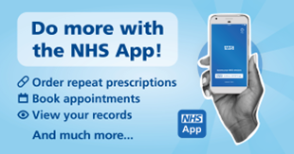  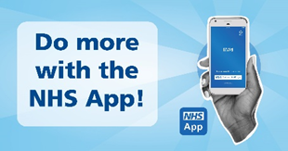  Instagram  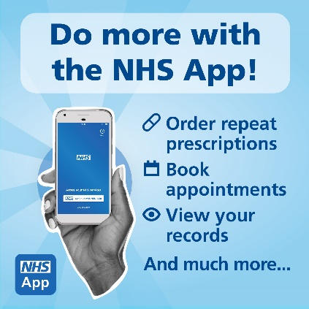  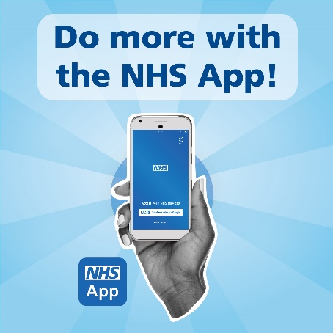
Method | Message  Get message through the NHS App | Image
Website/Newsletter copy | As your GP practice we are now able to send messages via the NHS App.  NHS App messaging is a new service and it is your choice whether to receive messages in this way. If you decide to opt in, you will need to switch on NHS App notifications through your device.  To do this:  - Click the 3 dots at the top right of the home page  - Click account and settings  - Click manage notifications  - Ensure the send me notifications button is green as shown in the image below  Please note notifications preferences may take 24 hours to take effect.  If a message is not successfully delivered to the NHS App, your messaging service provider will automatically send a message via another channel such as SMS (text) to ensure you receives the message.  https://www.nhs.uk/nhs-app/nhs-app-help-and-support/messaging-in-the-nhs-app/ | Choose a generic image to fit your design  Include screenshot to demonstrate turning on notifications  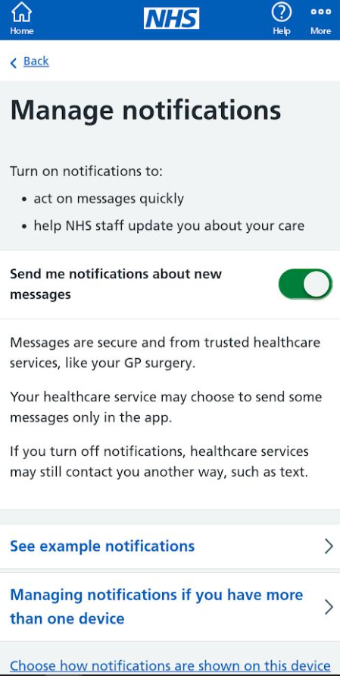
Text Message - Alerting patients to NHS App messaging function | [GP surgery name] can now send messages to the NHS App. Download the  NHS App and turn on notifications to see messages. Learn more https://www.nhs.uk/nhs-app/msg-service | n/a
Social media | We can now send messages to patients via the NHS App.  Download the NHS App and turn on notifications to see your messages. Learn more https://www.nhs.uk/nhs-app/msg-service  Please remember not to include links within Instagram messages as they are not clickable. They must be added to your bio if you wish to have them accessible. | 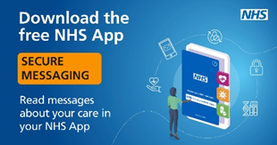
NHS App message template – First message to be sent in NHS App | You are now receiving messages through the NHS App Messaging Service.  This is a convenient and secure way for [GP surgery name] to send you messages about your care.  What to expect from [GP surgery name] messages  We will send you [amend examples as necessary]:  - appointment reminders  - test results  - changes to opening times  We will only send you a message if we need to contact you, for example if we have an update about your care.  We may continue to send you some information by SMS (text) message while we transition to using the NHS App Messaging Service.  If you do not want to receive messages from the NHS App Messaging Service  Contact [GP surgery name] to discuss your preferred contact method.  How to check if you have a message  You will receive messages here, in 'View messages from your GP surgery and other NHS Services.'  The best way to keep up with your messages is to download the NHS App on Google Play or the App Store and turn on notifications.  To check your messages:  - Log in to the NHS app.  - Go to View your messages.  - Select View messages from your GP surgery and other NHS Services.  - Then select [GP surgery name].  Get NHS App notifications when we send you a message  To turn on notifications:  - Log in to the NHS app.  - Go to More.  - Select Account and settings.  - Then select Manage notifications.  - Use the toggle to turn notifications on or off.  You will see a new notification from the NHS App the next time we send you a message. Your notifications will tell you that you have a new message from your GP.  You will still receive our messages if your notifications are turned off, but you will not see a notification on your device when you have a new message.  How to contact [GP surgery name]  [Here you explain how patients can contact your surgery - amend/delete as necessary]  For example:  - phone [add practice number] or email [add practice email address]  - personal health records (PHRs) or online consultation forms (OLCs) in the NHS App - for example click ‘Ask your GP a question’ – make sure you include the provider’s name, like eConsult  Your privacy while using the NHS App  If you want to find out how the NHS uses your information, read the NHS account privacy policy. | n/a
Method | Message  Order your repeat prescriptions via the NHS App | Image
Website/Newsletter copy | Did you know you can manage repeat prescriptions from [your GP surgery name] in the NHS App?  You can easily choose where your prescriptions are sent. So, if you know you'll be away from home or you are moving home, you can change your nominated pharmacy from within the app.  You can also order your prescription at any time that suits you. There’s no need to wait to join a telephone queue or wait until the GP surgery opens.  When ordering medications always check your cupboards first to ensure you really need it. Make sure you regularly check the expiry dates of your medications and for anything out of date or unused, dispose of it safely by returning it to your community pharmacy.  It’s easy to use, and, if you hit a snag, you can go to ‘Help’ in the top right-hand corner of the app or visit nhs.uk/helpmeapp.  Find out more about the NHS App at: www.nhs.uk/nhsapp. | Choose a generic image to fit your design
Social Media | Short Version  Did you know you can manage repeat prescriptions from [your GP surgery name] in the NHS App? You can easily change your nominated pharmacy and send orders when it’s convenient for you. Find out more: www.nhs.uk/nhsapp  Long Version  Did you know you can manage repeat prescriptions from in the NHS App?  You can easily choose where your prescriptions are sent. So, if you know you'll be away from home or you are moving home, you can change your nominated pharmacy from within the app.  You can also order your prescription at any time that suits you. There’s no need to wait to join a telephone queue or wait until the GP surgery opens.  When ordering medications always check your cupboards first to ensure you really need it. Make sure you regularly check the expiry dates of your medications and for anything out of date or unused, dispose of it safely by returning it to your community pharmacy.  It’s easy to use, and, if you hit a snag, you can go to ‘Help’ in the top right-hand corner of the app or visit nhs.uk/helpmeapp.  Find out more about the NHS App at: www.nhs.uk/nhsapp.  Please remember not to include links within Instagram messages as they are not clickable. They must be added to your bio if you wish to have them accessible. | Facebook / X (Twitter)  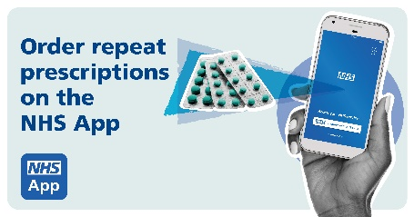  Instagram  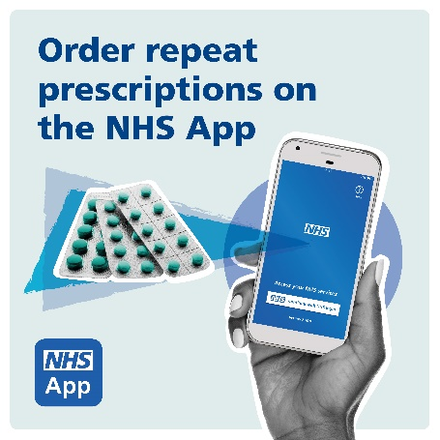
Text Message | Did you know you can manage repeat prescriptions from [your GP surgery name] in the NHS App? Find out how to do it: www.nhs.uk/nhsapp
Method | Message  Access your GP records with the NHS App | Image
Newsletter / Website copy | Option 1  As your GP practice, we are now providing you with access to your full medical record via the NHS app (and NHS website) if you have a suitable NHS login.  This is a contractual requirement for [your GP surgery name].  This means that you will have access to → new ← information added to your GP record, going forward ("prospective records access"). It does not automatically provide you with any historic (past) information, present in your record, prior to 4th October 2023.  We are aware that not everyone will want access to GP record in this way, and at this time, and some patients may have concerns about their personal medical records being made available on their smartphones or online, especially if other people have access to their devices or logins.  If you would like us to switch off prospective records access for the time being, then please do contact the surgery and we will disable it.  It will not disable any of the other features of the NHS App, such as medication requests or online appointment booking etc.  You can change your mind at any time by contacting the practice.  For information about the NHS App, see here:  https://www.nhs.uk/nhs-app/about-the-nhs-app  Further information about "prospective records access" is available here:  https://www.england.nhs.uk/.../11/pat-guid-need-to-know.pdf  or contact the Data Protection Officer for [your GP surgery name].  Option 2  Understanding all you can about your condition and what you need to do to stay as healthy as possible is one of the best ways of meeting your health goals.  Greta, who has an ongoing health condition, has access to her GP record and it has helped her manage her vitamin B12 deficiency. She said: “By looking at my blood tests and results, I can begin to understand what ‘normal’ means for me. Because normal is different for all of us. I look at my blood tests before I go to the doctor, so I can see my results and think about them before we speak. This means I can get questions ready in advance and feel informed at my consultation. To me, that is very, very important.”  Access to your GP record can be made through the free NHS App or online account. If you haven’t downloaded the NHS App to your smartphone or tablet, you can find out how to online at https://nhs.uk/helpmeapp. If you have the NHS App or an online account and you cannot see your record you can ask your practice to make it available to you. Once you have access, you will be able to see information from any consultations going forward.  [Insert name] our [insert role] said: “We have long campaigned for people to understand more about their health. If you can see what’s on your record and what your healthcare team have advised you to do, you can be in control of your health and on the path to leading a long and healthy life.”  Vin Diwakar, Medical Director for Secondary Care and Transformation for NHS England, said: “We believe it is every patient’s right to see the health information held about them on their GP record, that it is their information, and it should be easily accessible. This standard of care means you will be able to read your notes and better understand your own health.”  The NHS is interested in hearing from anyone who already has access to their online GP record. Please contact [insert name and email] if you think you can help | Choose a generic image to fit your design
Social Media | Short version  Have you accessed your GP health records via the NHS App yet? Its simple learn more at https://www.nhs.uk/nhs-app/nhs-app-help-and-support/health-records-in-the-nhs-app/  Long Version  As your GP practice, we are now providing you with access to your full medical record via the NHS app (and NHS website) if you have a suitable NHS login.  This is a contractual requirement for [your GP surgery name].  This means that you will have access to → new ← information added to your GP record, going forward ("prospective records access"). It does not automatically provide you with any historic (past) information, present in your record, prior to 4th October 2023.  We are aware that not everyone will want access to GP record in this way, and at this time, and some patients may have concerns about their personal medical records being made available on their smartphones or online, especially if other people have access to their devices or logins.  If you would like us to switch off prospective records access for the time being, then please do contact the surgery and we will disable it. | Facebook / X (Twitter)  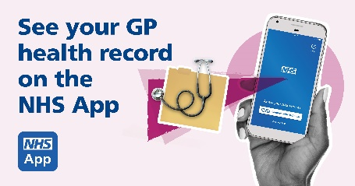  Instagram  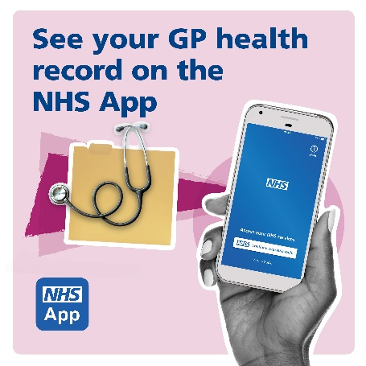
NHS England Case Study | Greta started experiencing problems with her feet a few years ago and was later diagnosed with B12 deficiency. By accessing her GP health record, Greta can take control of her own health and care.  ‘My experience started a few years ago, when my doctor first told me about accessing my GP health record on my phone. At this stage, I looked at the odd blood test and just found it interesting. But it really came in handy for me recently.  I initially started having some problems with my feet and later, in January 2022, I was diagnosed with B12 deficiency. This meant I was seeing the doctor more regularly and having more tests.  Being able to view my GP health record has made it easier for me to understand and manage my condition.  If I’m unsure about what something in my record means, I just Google it. When I speak to my doctor, I want to talk about my condition and how I can get better. Not spend time asking for clarification. I can do that at home. For me, it’s about taking control.  By looking at my blood tests and results, I can begin to understand what ‘normal’ means for me. Because normal is different for all of us. I look at my blood tests before I go to the doctor, so I can see my results and think about them before we speak. This means I can get questions ready in advance and feel informed at my consultation. To me, that is very, very important’. | 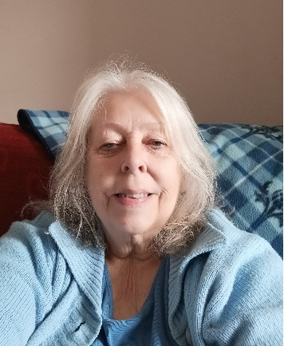

Frimley health and care Integrated Care System will be supporting the uptake of the NHS App across the geography. As a reminder their social media channel are:
Facebook: https://www.facebook.com/FrimleyHealthandCare/
X (formerly Twitter): @FrimleyHC
Instagram: @frimleyhealthandcareics

