Highlighting the members of your team this winter
We’ve heard from practices that it can feel overwhelming to know where to start in sharing practice improvements around appointments, telephone systems, digital advances, and the multi-skilled team with your patients and so we want to help.
As a system we are consistently developing and sharing with patients the following messages about general practice.
- We’re listening and making improvements.
- There are 3 ways to get in touch with your GP practice
- Appointments are available 8am-8pm and at weekends, you may be offered an appointment at a location that is not your usual surgery
- For out of hours contact NHS 111 online, call 111 or through your NHS App you can check your symptoms
- A larger multi skilled team is now available at your practice to offer more holistic care
- Improved digital options such as telephony systems and improvements to apps like the NHS App and Frimley Healthier Together are supporting patients to get the help they need at a time convenient to them

Over the coming weeks we will be sharing a pack a week which has a specific messaging focus and helping you share good news with your patients.
This week (11 December) we want to focus on the role of the Paramedic Practitioner.
The table below contains suggested wording for website and/or newsletters, social media wording, images/videos and a text message template for use in practice.
We have included resources that we have available but that shouldn’t stop you personalising what you share to ensure it reflects your practice.
Ideas you could use:
- Promote the role of paramedic practitioner through your reception, social media channels and via your teams and networks
- Share an image of your paramedic practitioner as an introduction to them
- Explain why patients may be booked an appointment with the paramedic rather than a GP
- If your paramedic has a specialists area of expertise, or run certain clinics, share details of these with patients
- Have you recently received positive feedback about your paramedic practitioner from a patient? Would the patient be willing to have that shared more widely?
- Could you make a quick video, filmed on your phone, where your paramedic practitioner introduces themselves and their role?
- Could your PPG or other patient/community partners assist you in sharing these messages?
We also have a Paramedic Practitioner case study available for download and use
Remember if you are sharing images and videos of staff of social media ensure they are fully aware of what their image will be used for and follow your in-house process for recording consent.
In addition to the information below we have winter and service messages available for you on our campaigns resource page.
Method | Message  Meet the team – Paramedic Practitioner | Image
Website / Newsletter copy | Have you met your paramedic practitioner?  Paramedic practitioners have become vital team members within your GP practice.  Their background in out of hospital care means that they are used to working with people with a variety of health conditions – from coughs and minor injuries, to more serious conditions such as asthma and heart conditions.  They work alongside GPs to help manage routine or urgent appointments, as well as telephone triage (assessment or urgency of illness or injury) and in some cases offer home visits.  GP practices are committed to providing more holistic care through their multi skilled team and because of the range of expertise available, a GP might not always be the most suitable person to help you with your need.  Paramedics offer specialist skills and knowledge to support patients who might require an urgent appointment or even a home visit often keeping the patient from needing further treatment.  If a patient has more complicated problems, paramedics can ask the GP or another specialist in the team to support with a patients needs.  *Local Paramedic Practitioner Karl told us “I have been a paramedic for 22 years, beginning my career as a technician and moving through various levels of training to become a paramedic practitioner working in general practice.  “I love the variety of my work and the time that my role allows me to spend with patients who are often needing to see someone for a same day issue that needs assessment.  “Working as part of an integrated team, that has so many colleagues with specialist areas of expertise, I am able to check in whenever I need to with a pharmacist or GP colleague, ensuring we are offering the patient the most comprehensive wrap around care for the best treatment, with the best outcome.  “I can spend more time with patients which means I can better answer their questions. This also helps me understand their worries. Sometimes it becomes clear that there are other issues we can support with, and if that's the case, I am able to refer to colleagues or share information about social prescribing as it may be able to help.  “We are able to offer so much more at the surgery now. I would urge people to be clear on their need when they contact their surgery so that we can assist them to get to the right member of the team and be seen quickly."  Find out more about the multi skilled team within your practice. Visit https://www.frimleyhealthandcare.org.uk/gethelp  *Can be exchanged for your own paramedic’s quote. | Choose your own image, take your own picture or use one from below.  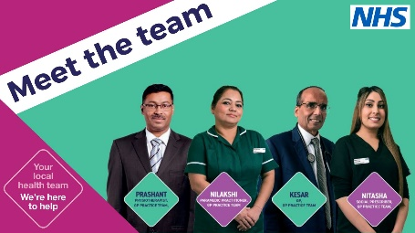  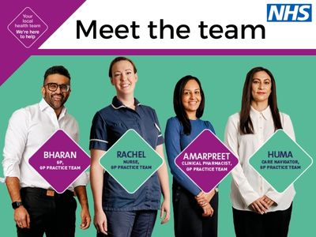
Text message template | We now have Paramedic Practitioners working with the practice. They support with urgent appointments and assessments. Find out more https://www.frimleyhealthandcare.org.uk/gethelp  Link can be exchanged for own website if team role information populated | n/a
Social Media | Link can be exchanged for your own team profiles if up to date and available on your practice website. We suggest adding photos to help patients get to know your team.  Short version  Paramedic Practitioner is just one of the roles in our multi skilled health team providing the care support you need. Learn more https://www.frimleyhealthandcare.org.uk/gethelp  #MeetYourParamedic  Long Version  Paramedic Practitioner is just one of the roles in our multi skilled health team providing the care support you need.  We have a large team now and you may be supported by a nurse, a GP, a Clinical Pharmacist, or another colleague when you contact us depending on who has the best expertise to help you.  No matter if you contact us online, on the phone or you pop in, answering questions as fully as possible helps the reception team direct your need to the best team member, or service to help you.  Appointments are available 8am – 8pm and at weekends, you may be offered an appointment on the phone, online, in person or at a location different to your usual surgery.  Learn more https://www.frimleyhealthandcare.org.uk/gethelp  #Yourlocalhealthteam #MeetYourParamedic  Please remember not to include links within Instagram messages as they are not clickable. They must be added to your bio or on stories if you wish to have them accessible. | Film clip avilable for download and use on social media via https://www.frimleyhealthandcare.org.uk/professional-resources/communication-resources-for-system-partners/general-practice-access-and-team/  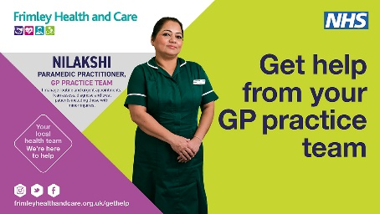  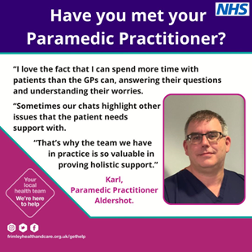  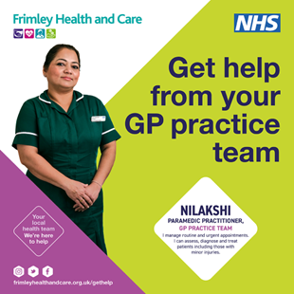
Method | Message  General GP Practice messaging – Always on | Image
Website/Newsletter copy | GP practices across the Frimley Health and Care area have been welcoming new members of staff into their teams to better support patients’ needs.  Around 400 additional team members have been recruited into healthcare roles at general practices in our area since 2019/2020 - offering patients access to an expanded team of health professionals in addition to their practice GP or nurse.  GPs are now supported by this larger team that includes pharmacists, mental health practitioners, paramedics and social prescribers, who work together to support patients to get the right care when needed.  We have continually been working hard to improve patient experience and access to our team, recently this has included adopting new digital phone systems which allow a call back, informed queuing and signposting to services if appropriate.  The NHS is training more staff to better assess patients’ needs when they first make contact ensuring they can be seen by the right health professional. For example, if you have muscular pain, you can be booked straight in to see a physiotherapist.  When you get in touch, you will be asked what you need help with. The information you provide will be used to help choose the most suitable doctor, nurse or other health professional in the team to help or you may be signposted to a more appropriate service.  You can always tell us:  - If there’s a specific doctor, nurse or other health professional who you would prefer to respond to you  - If you would prefer to consult by phone, face-to-face, by video call, text or email  - If you need an interpreter  - If you have any other access or communications needs.  Through the expansion of the team, we are now better able to support patients in more holistic ways, including with non-medical requirements. Non-medical issues can impact significantly on a person’s health and wellbeing, and this is where GP practice Social Prescribers can help. By working alongside patients to understand and identify issues such as loneliness, or where help is needed around debts and housing concerns, social prescribers can support the patient in making connections with local council services and local voluntary services, helping to improve their situation and in turn their health and wellbeing.  Even though GP practice teams have been growing for several years now, public awareness of the range of support available remains low, however more than 73% of people surveyed said they were happy to receive care from another health worker, recognising they didn’t always need to see a GP.  Lalitha Iyer, Chief Medical Officer, NHS Frimley said “Record numbers of people are seeking support from their GP practice, with teams across the country treating half a million more patients a week compared with before the pandemic. The NHS must adapt its services to match the increasing demand in a sustainable way.  “Not only have we been growing the teams within GP practices, but we have also been listening to feedback and making improvements to our systems. There are three ways you can contact your practice – online, on the phone and in person which is providing more choice. Phone lines have been improved; reducing waiting times, providing a clearer indication of place in the queue, and offering a call back option.  “We have also increased capacity, providing extended appointment times 8am-8pm and at weekends. Digital support like the NHS App is making it even easier to order repeat prescriptions and view your medical records.  “Reception teams, are trained to ensure you see the best member of the team for your need. Anything you discuss with them is in confidence and answering questions fully will help ensure we can get you to the right person within the team.”  To help explain the support available, a new film has been released by NHS England, which sees three curious children go behind the scenes at a general practice to meet some of these professionals and learn more about how they help patients get the care they need.  We are committed to continually improving the experience of our patients in accessing the services, so please support us to help you.  Please consider exchanging highlighted quote for one from your own team.
Text Message  Supporting access | Contact us online, on the phone or pop in. Answer questions fully to help us help you. Appointments 8am-8pm and at weekends. You may be offered an appointment at a different location. | n/a
Social media | Option one:  There are three ways to get in touch with us:  You can use the online form on the practice website. It’s convenient and secure and can save time.  Call during surgery hours. Check the practice website for opening hours.  Visit the surgery in person  #Yourlocalhealthteam  https://www.frimleyhealthandcare.org.uk/gethelp  Option two:  Did you know if you’re feeling unwell, you don’t necessarily need to see a doctor.  We have a multi skilled team here to help. You have an appointment made with a GP, Nurse, Clinical Pharmacist or another colleague when you contact us, depending on who has the best expertise to help you.  #Yourlocalhealthteam  www.frimleyhealthandcare.org.uk/gethelp  Respect  The team are working hard to support you with your need. Please treat us with respect and answer questions as fully as possible so we can direct you to the best member of the team of service to help you. Thank you.  #YourLocalHealthTeam  Please remember not to include links within Instagram messages as they are not clickable. They must be added to your bio if you wish to have them accessible.  Respect  The team are working hard to support you with your need. Please treat us with respect and answer questions as fully as possible so we can direct you to the best member of the team of service to help you. Thank you.  #YourLocalHealthTeam  Do you have all the information you need to help you still well this winter. Ensure you know how to contact us and when to get in touch. Learn more about choosing the right service visit: https://www.frimleyhealthandcare.org.uk/your-health/choose-the-right-service/  #YourLocalHeathTeam | 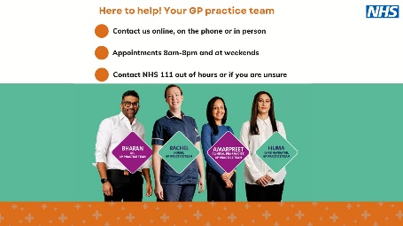  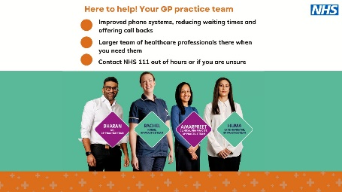  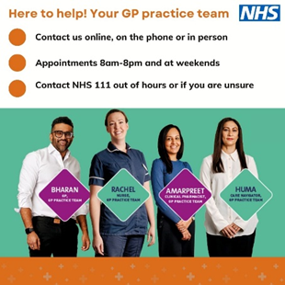  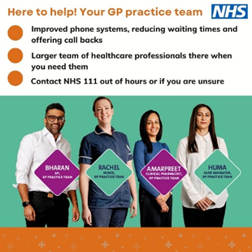  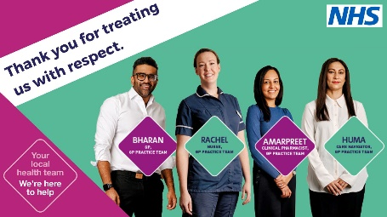  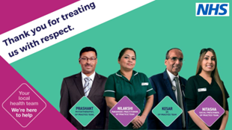  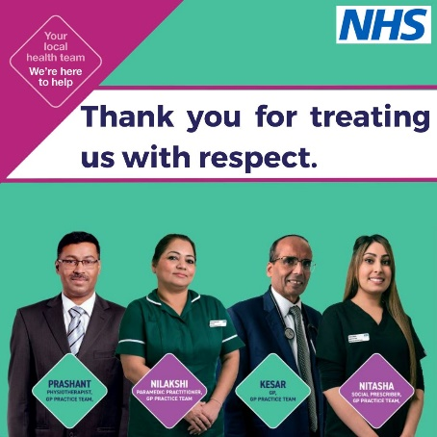    Additional Image  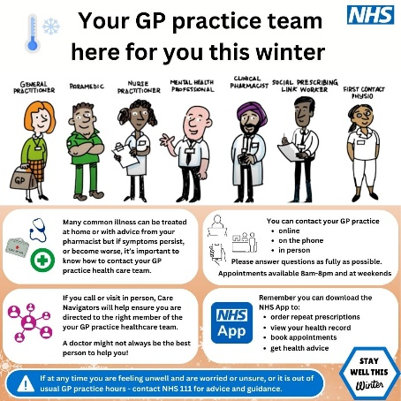

As a reminder The Frimley Health and Care social media channels that will be sharing these messages are:
Facebook: https://www.facebook.com/FrimleyHealthandCare/
X (formerly Twitter): @FrimleyHC
Instagram: @frimleyhealthandcareics

