Alcohol Awareness messaging
February 2024 onwards

According to Alcohol Change, there are an estimated 602,391 dependent drinkers in England – yet only 18% of them are receiving treatment.
24% of adults in England and Scotland regularly drink more than the Chief Medical Officer’s low-risk guidelines, and 27% of drinkers binge drink.
In the UK there were 8,974 alcohol-specific deaths in 2020 and 7,558 in 2021 (equating to between 13 and 14 per 100,000 people). The number of male alcohol-specific deaths was higher than female, with the highest proportion being among men aged 55 to 59. (Office for National Statistics - Alcohol-specific deaths in the UK)
Alcohol causes seven types of cancer, including breast, mouth and bowel cancer, as well as being a factor in dementia. Regularly drinking alcohol is associated with a higher risk of developing breast cancer and whatever your drinking habits, cutting down will reduce your risk.
In 2020 approximately 5,920 people were killed or injured in a collision in which the driver or rider was over the legal blood alcohol limit.
Within Frimley Health and Care we are looking to increase our visibility on tackling alcohol dependence. We want to make information on the risks more widely known, in order to encourage people to take action, so they can improve their health and reduce their future need for clinical intervention. We also want to raise the profile of the available treatment options, to increase the numbers of people being successfully supported by the services.
To do this we have developed content for a new alcohol awareness section of the Frimley Health and Care website and we are developing messages to be used on our channels and shared with partners.

As messaging emphasising the physical and mental health dangers of excess alcohol have been in existence for many years, we are looking to take a different approach. Rather than try to appeal to the individuals who have a drink problem, we’re looking to appeal to the love and affection of their family members and friends. We will be highlighting some of the main tell-tale signs of drink dependency to tip people off to the fact that their loved one or friend may have a problem.

The following are suggested as social media messages – for adaptation for different platforms.

Core message | Image
If you're worried about someone's drinking habits, expressing your concern isn't just an act of care; it can be a catalyst for positive change.  Find out how to help here: | 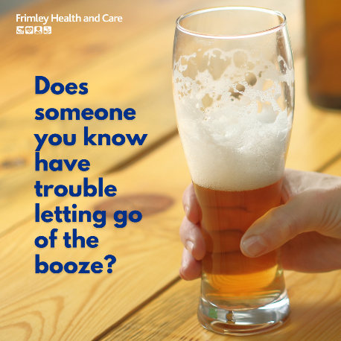
Many people who are alcohol-dependent are in denial & it’s the love & support of those around them that can be the key to turning themselves around. Find out how to help here: | 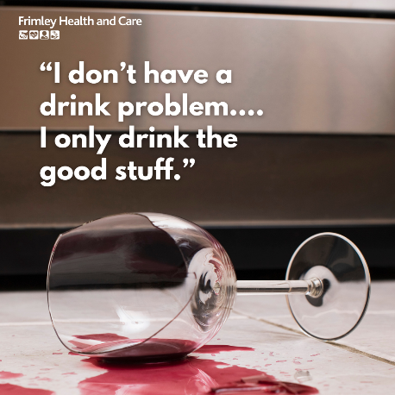
True friendship is about caring enough to notice when things seem off. If you've seen signs of alcohol dependency in a friend, let them know you're there to help them out of the hole. | 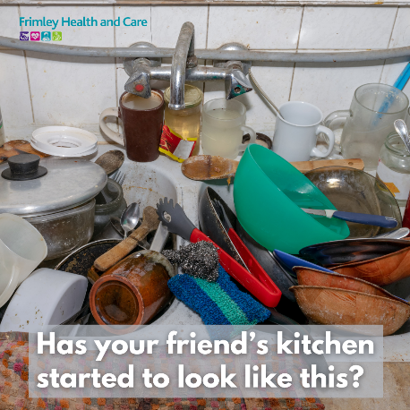
Alcohol dependency can pull someone’s life apart piece by piece. With your love & support they can help to build it up again. Find out how you can help here: | 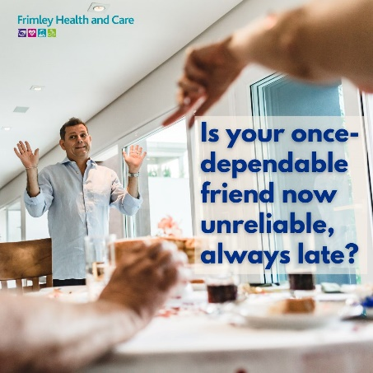
If you've seen signs that someone you care about is struggling with alcohol, a gentle word from a friend can be the start of their recovery. Learn what you can do here: | 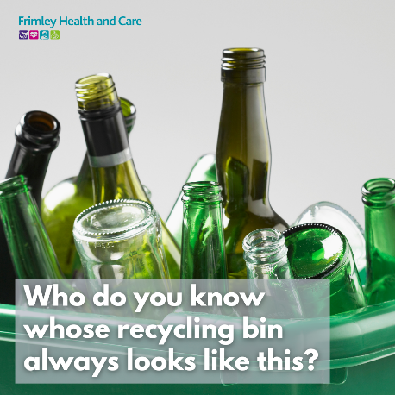
Alcohol dependency can lead to a cycle of drinking, drunkenness, recovery & repeat. Your love & support can play a vital role in breaking that cycle. Find out more here: | 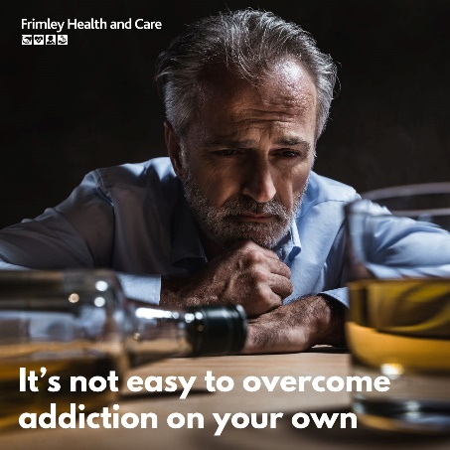
Alcohol abuse can lead to increased aggression. It’s terrible to see friends always in trouble. Find out what you can do to help them change: | 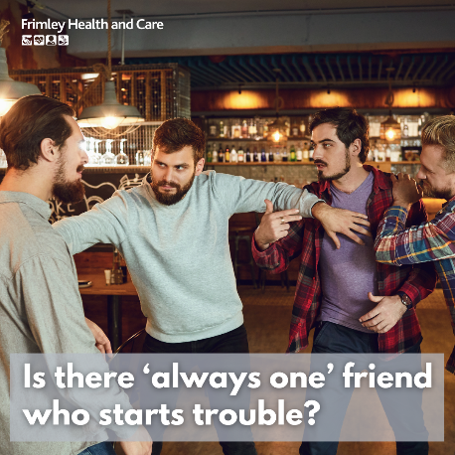
You can feel helpless watching a friend fall into a spiral of alcohol dependency, yet you can help them. Find out how here: | 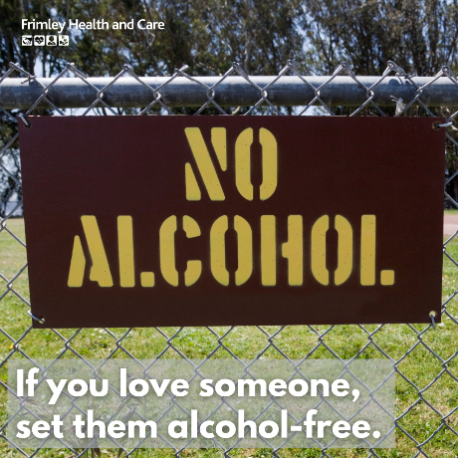

Posts on the Frimley Health and Care ICS channels will link to the Frimley Health and Care website alcohol awareness pages. Partners may wish to link to local services where they are.

