Channel | Message | Image
Facebook | Protect Yourself with the RSV Vaccine  Respiratory Syncytial Virus (RSV) can lead to pneumonia, a serious condition, especially in older adults. The good news is that you can protect yourself by getting the RSV vaccine.  Free RSV Vaccination Eligibility:  You will be invited for your free RSV vaccination if:  *You turn 75 years of age on or after 1 September 2024.  *You are already aged 75 to 79 years old on 1 September 2024.  For more information on the RSV vaccine visit https://ukhsa.blog.gov.uk/2024/07/17/what-is-rsv-and-is-there-a-vaccine/ or speak to your practice nurse, GP, or health team.  #RSV | 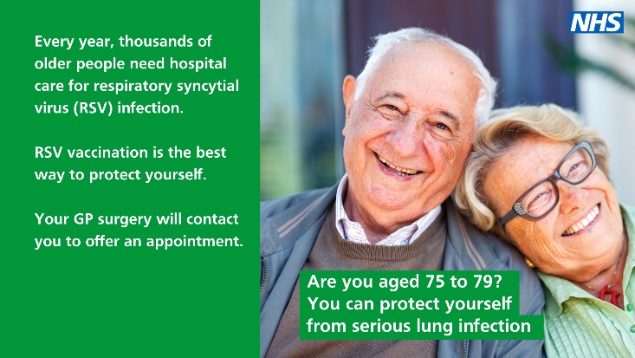
Facebook /Instagram (remove link) | Respiratory syncytial virus (RSV) is a major cause of respiratory illness in the UK but is relatively unknown to the public.  This new vaccine being offered from 1 September 2024, creates huge opportunities to prevent severe illness in those most vulnerable to RSV, helping to protect lives and ease winter pressures for the NHS.  For more information visit https://www.frimleyhealthandcare.org.uk/news/posts/2024/august/nhs-expands-seasonal-vaccination-programme-with-the-introduction-of-rsv-vaccine/
Facebook /Instagram (remove link) | Respiratory syncytial virus (RSV) is a respiratory virus that affects the lungs.  RSV is very common, and it can be serious for babies and older people.  From 1 September 2024, you may be eligible for a free RSV vaccine if you at least 28 weeks pregnant or aged 75-79 years old.  Read more about RSV here: https://www.frimleyhealthandcare.org.uk/news/posts/2024/august/nhs-expands-seasonal-vaccination-programme-with-the-introduction-of-rsv-vaccine/ | 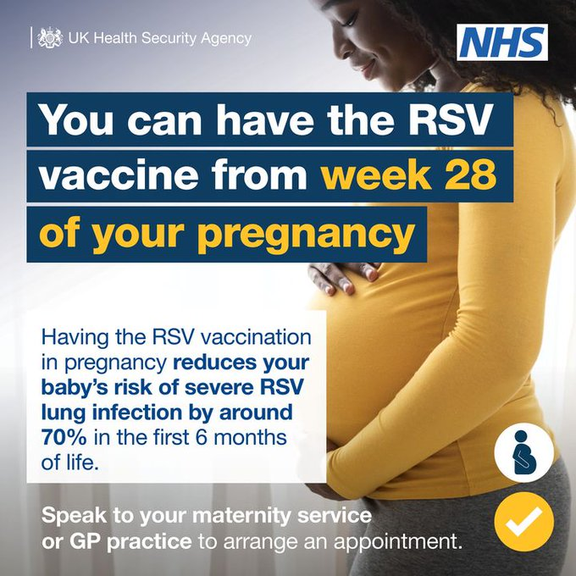
Facebook /Instagram (remove link) | RSV accounts for around 30,000 hospitalisations of children under 5 in the UK annually, and for 20 to 30 infant deaths. From the 1 September if you are at least 28 weeks pregnant you can receive a free RSV vaccine to protect your baby. More information can be found here https://www.frimleyhealthandcare.org.uk/news/posts/2024/august/nhs-expands-seasonal-vaccination-programme-with-the-introduction-of-rsv-vaccine/ | 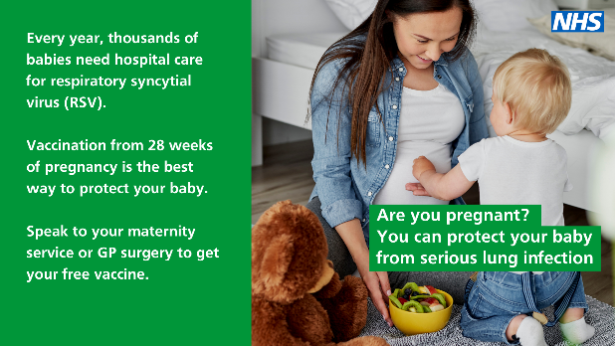
Facebook /Instagram (remove link) | RSV can also be severe in older adults, causing pneumonia and flare-ups of existing lung disease and other long-term conditions. It causes around 9,000 hospitalisations in those aged over 75 in the UK each year. From the 1 September if you are aged 75-79 years old you are eligible for a free RSV vaccine. More information can be found here https://www.frimleyhealthandcare.org.uk/news/posts/2024/august/nhs-expands-seasonal-vaccination-programme-with-the-introduction-of-rsv-vaccine/ | 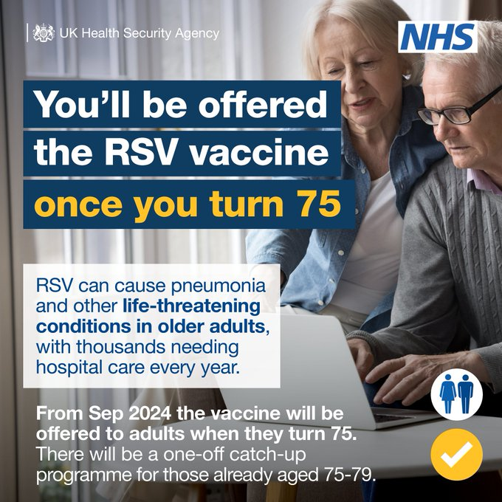
X | Aged 75-79? Protect yourself with the RSV vaccine this September. RSV can be severe in older adults, causing pneumonia and flare-ups of existing lung disease and other long-term conditions. For more information visit https://www.frimleyhealthandcare.org.uk/news/posts/2024/august/nhs-expands-seasonal-vaccination-programme-with-the-introduction-of-rsv-vaccine/ | 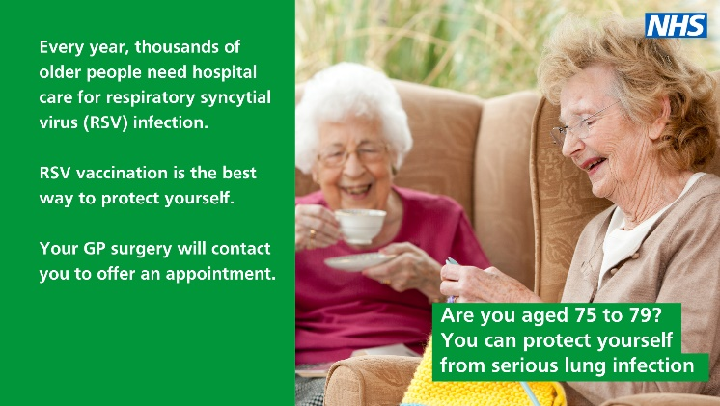
X | Are you at least 28 weeks pregnant? Protect your baby with the RSV vaccine this September. RSV accounts for around 30,000 hospitalisations of children under 5 in the UK annually, and for 20 to 30 infant deaths. More information can be found here https://www.frimleyhealthandcare.org.uk/news/posts/2024/august/nhs-expands-seasonal-vaccination-programme-with-the-introduction-of-rsv-vaccine/ | 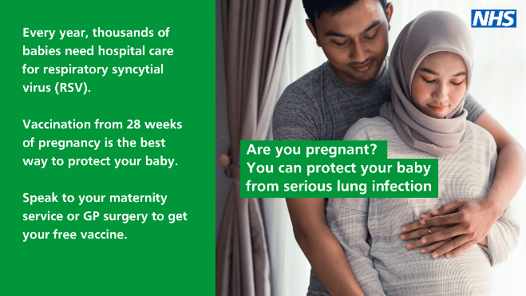
 | RSV social media images for launch
Facebook /X /Instagram (remove link) | Respiratory syncytial virus (RSV) can cause lung infections like bronchiolitis, making it difficult for newborn babies to breathe and causing 20,000 infants to need hospital treatment each year.  Talk to your GP or maternity service to schedule yours from 28 weeks of pregnancy. | 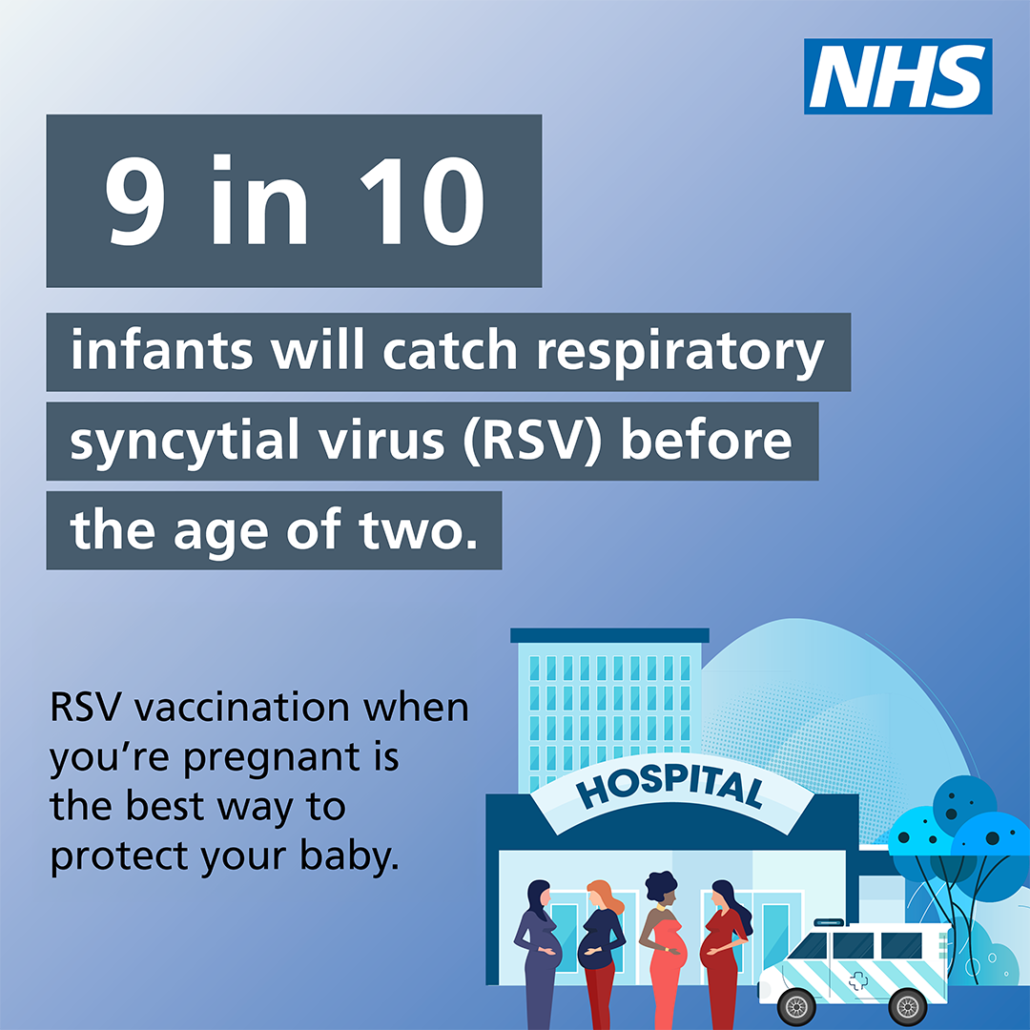
Facebook /X /Instagram (remove link) | People aged 75-79 can get a free vaccination to protect themselves from respiratory syncytial virus (RSV), a common lung infection that can lead to serious illnesses like pneumonia.  Read more about RSV vaccination here: https://www.nhs.uk/conditions/respiratory-syncytial-virus-rsv/ | 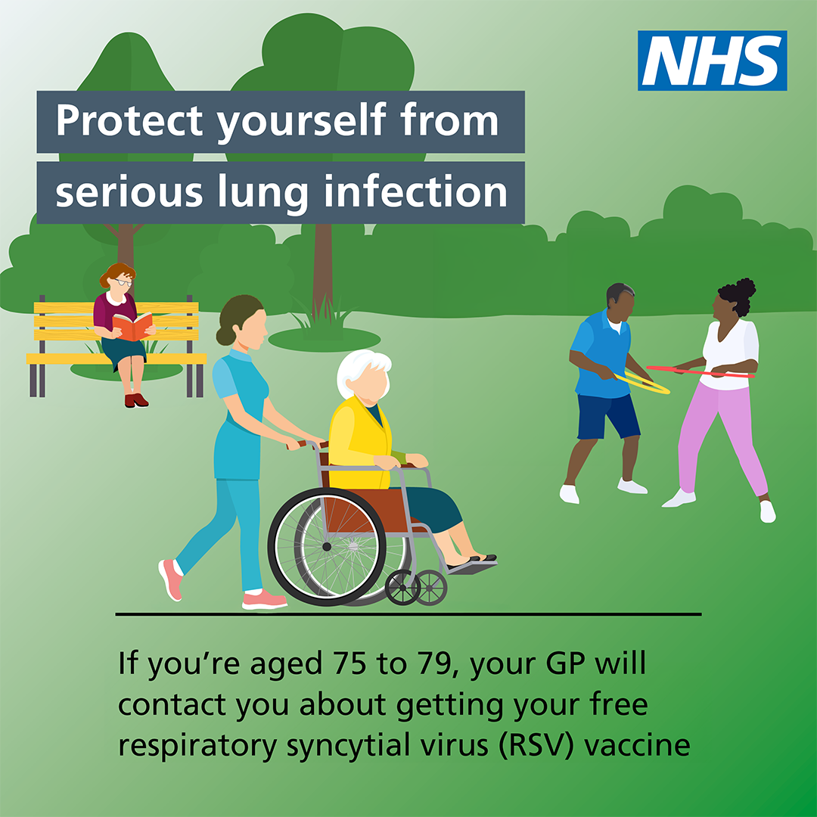
Facebook /X /Instagram (remove link) | Pregnant women are eligible for a free respiratory syncytial virus (RSV) vaccine to protect their babies from serious lung infections.  You can get your vaccine from 28 weeks of pregnancy. Talk to your GP or maternity service to schedule yours.  Read more: https://www.nhs.uk/conditions/respiratory-syncytial-virus-rsv/ | 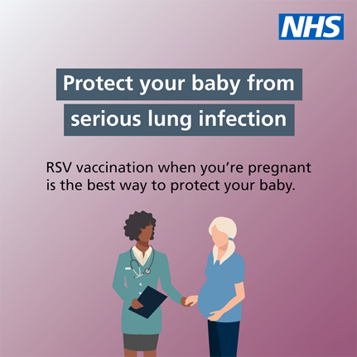
Instagram story | Link - https://ukhsa.blog.gov.uk/2024/07/17/what-is-rsv-and-is-there-a-vaccine/ | 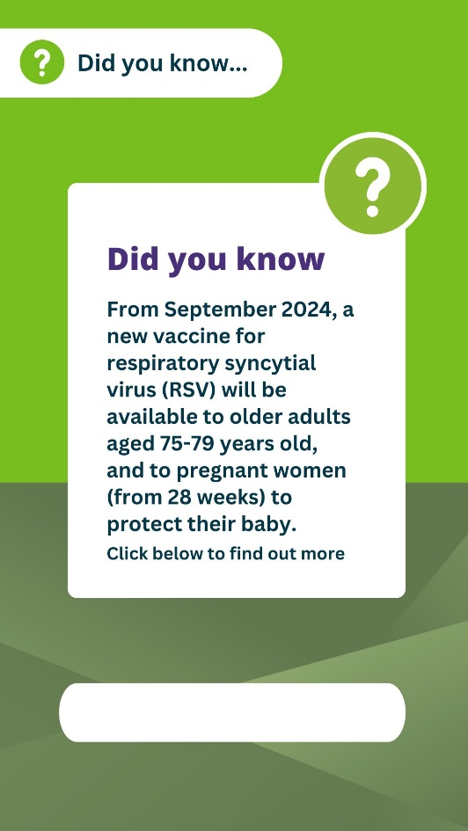
 | No link | 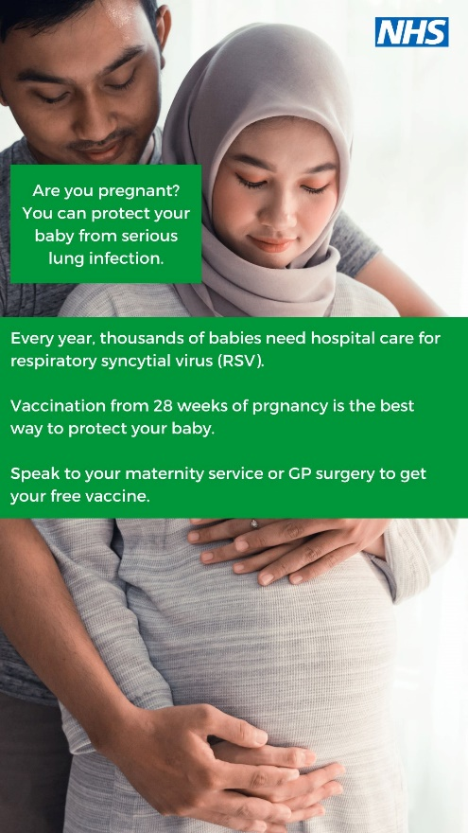
 | No link | 