Social media visuals and suggested copy
Post Copy | Image/Animation
LONG: To provide you with the best care, health and social care professionals need the most up to date information about you.  Thanks to the way health and social care organisations now work together and investment in technology, health and social care records can now be shared electronically with the professionals involved in your care.  Find out how we are improving health and care by connecting information at https://www.frimleyhealthandcare.org.uk/sharedcarerecord  #DataSharingFrimley  SHORT: To provide you with the best care, health and social care professionals need the most up to date information about you.  Find out how we are improving health and care by connecting information at https://www.frimleyhealthandcare.org.uk/sharedcarerecord  #DataSharingFrimley | 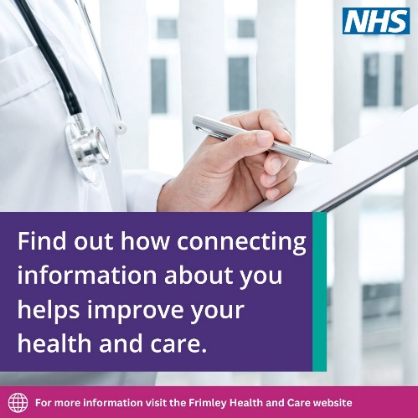
LONG: By quickly and securely sharing recorded information about your health and care, such as illnesses, hospital admissions and treatments, health and care workers can make the best choices about your care.  Find out how information about you is shared and used by health and care professionals involved in your care at https://www.frimleyhealthandcare.org.uk/sharedcarerecord  #DataSharing  SHORT: Find out how information about you is shared and used by health and care professionals involved in your care at https://www.frimleyhealthandcare.org.uk/sharedcarerecord  #DataSharingFrimley | 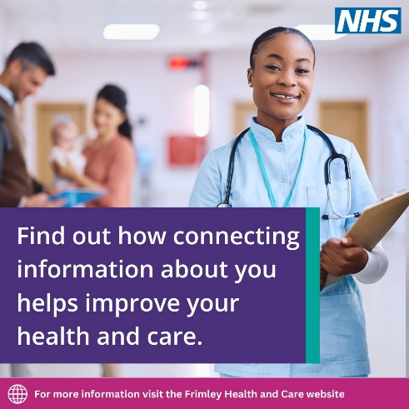
LONG: Thanks to the way health and social care organisations now work together and investment in technology, health and social care records can now be shared electronically with the professionals involved in your care.  Find out how we are improving health and care by connecting information at https://www.frimleyhealthandcare.org.uk/sharedcarerecord  #DataSharingFrimley  SHORT: Your health and social care records can now be shared electronically with the professionals involved in your care.  Find out how we are improving health and care by connecting information at https://www.frimleyhealthandcare.org.uk/sharedcarerecord  #DataSharingFrimley | 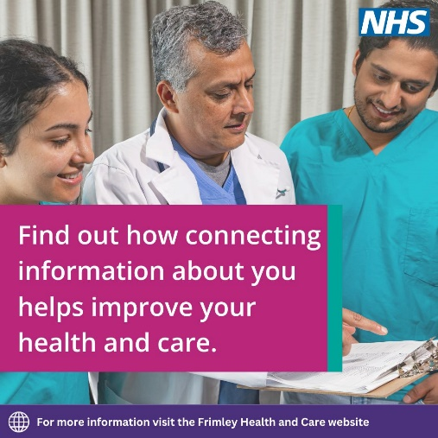
Health and care organisations are improving your health and care by connecting information.  Find out more at https://www.frimleyhealthandcare.org.uk/sharedcarerecord  #DataSharingFrimley | 