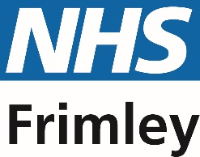
Dear parent / carer,

Does your child or young person have a learning disability?

Frimley Integrated Care Board are contacting students from year 9 at local special schools at their EHCP annual review, as well as sharing this at other relevant opportunities, as it is important to make you aware of an NHS service that your child might be entitled to. As your child attends a local specialist educational provision, specifically Kennel Lane School, Arbour Vale School, Manor Green School or Portesbery School, it is likely that your child meets the criteria to be considered as having a learning disability.

A learning disability is:
‘A significantly reduced ability to understand new or complex information, to learn new skills (Significantly impaired intelligence)
AND A reduced ability to cope independently, (Impaired social / adaptive functioning)
AND Which started before adulthood (onset before aged 18) with a lasting effect on development’ (NHS Leeds and York Partnership).

Evidence shows that having a learning disability might make it harder for your child to access mainstream health services and get the healthcare they need, particularly as they transition to adult services.

All people with a learning disability (even if it is mild) can be added to their GP practice Learning Disability Register. Everyone over the age of 14 on the Learning Disability Register is entitled to a free annual health check at their GP surgery. This health check will help to monitor your young person’s health and could help signpost to other specialist services.

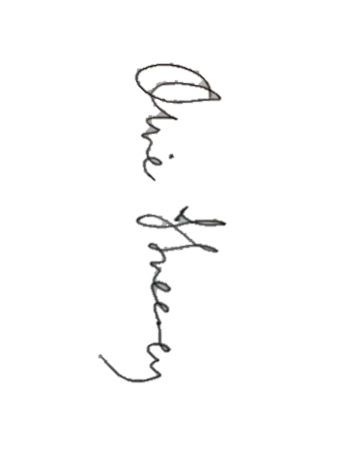
Please fill in the attached form and send to your child’s GP surgery addressed to ‘the Practice Manager’ in an envelope marked private and confidential.

Yours faithfully,

Dr Oliver Sweeney
Clinical Lead for Learning Disability - Frimley Integrated Care Board

Learning Disability Register Request Form
Private and confidential

Dear Practice Manager,

Full name of child / young person: _____________________________________________

Date of birth: _______________________________________________________________

School attending:

This young person has a learning disability and should be added to the learning disability register.

If you have any information regarding your child that we may find useful please share below:

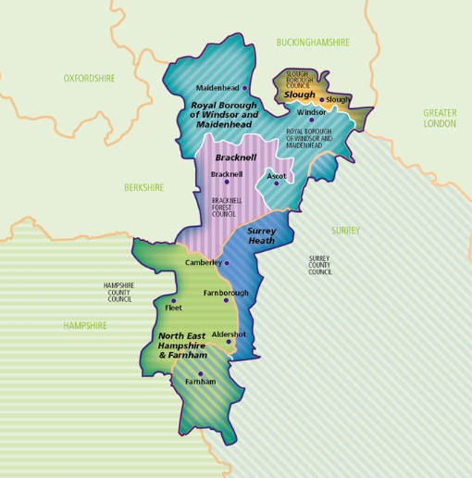
__________________________________________________________________________________________________________________________________________________________________________________________________________________________________________________________________________________________________________________________________________________________________________________________________________________________________________________________________
Please note that this form can only be used for GP surgeries within the Frimley Integrated Care System. For more information go to https://www.frimleyhealthandcare.org.uk/about/frimley-health-and-care-communities-map/

The eligibility for the learning disability register and annual health checks is national. Anyone registered to a GP practice outside of Frimley ICS may still wish to discuss with their practice.

