N.B. For Instagram posts, please remove any links.
For all our winter campaign assets, please visit: Communication resources for system partners.

Pharmacy Images
Copy | Image 1 | Image 2 | Image 3
LONG: You don’t always need your GP, ask your pharmacist first!  Did you know that pharmacists can help children aged from 1 to 17 yrs with earache symptoms that are not eased by pain relief!  Community pharmacies offer NHS services, they are qualified healthcare professionals who can offer clinical advice on many minor illnesses and ailments.  Find your closest pharmacy and their opening hours at nhs.uk/find-a-pharmacy  #MakeTheRightChoiceThisWinter  SHORT: Did you know that pharmacists can help children aged 1 - 17 yrs with earache symptoms that are not eased by pain relief! You don’t always need to see your GP.  Find your closest pharmacy at nhs.uk/find-a-pharmacy  #MakeTheRightChoiceThisWinter | 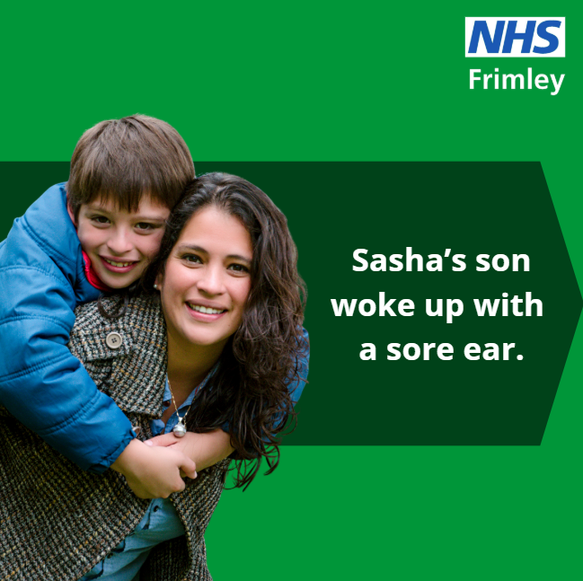 | 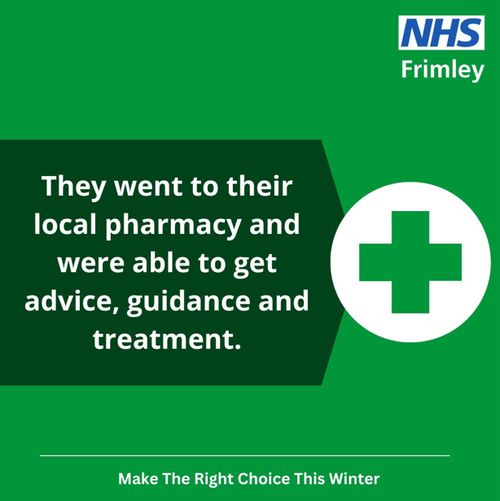 | 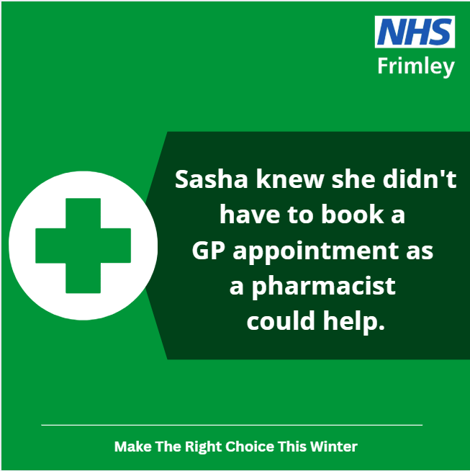
SHORT: Your local pharmacy can offer expert medical advice on a range of conditions that do not need a prescription.  Most pharmacies can also offer prescription medicine for some conditions, without you needing to see a GP or make an appointment.  This winter, think Pharmacy First and seek help before it gets worse.  #MakeTheRightChoice #StayWellThisWinterFrimley | 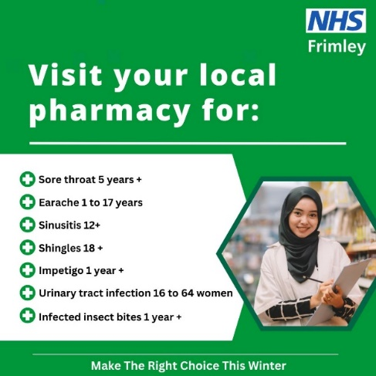  Pharmacy – seven conditions | 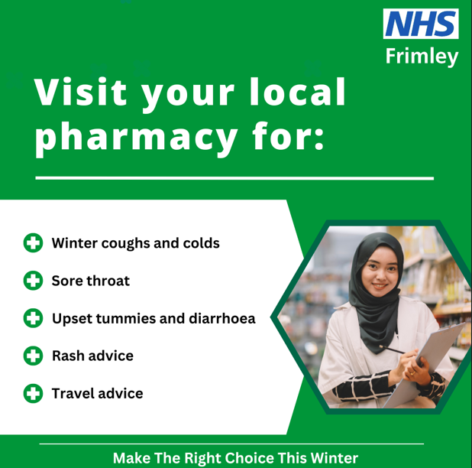  Pharmacy – common conditions

111
Copy | Image 1 |  | Image 2 |  | Image 3
Worried? Unsure? Use NHS 111 online, call 111 or access via the NHS App for when you need urgent medical help.  Get assessed and directed to the right place for you  nhs.uk/111  #MakeTheRightChoiceThisWinter | 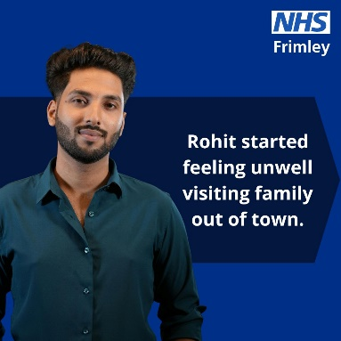 |  | 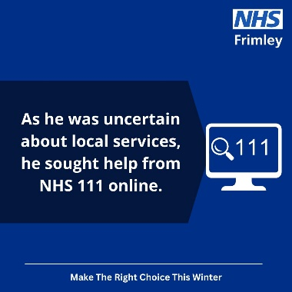
Frimley Healthier Together
Copy | Image 1 |  | Image 2 |  | Image 3
LONG: Give yourself a break from Dr Google when the children are unwell.  Frimley Healthier Together provides reliable, concise NHS advice about childhood health conditions and so much more, 24/7 through the website or app. Find:  - advice on what 'red-flag' signs to look out for  - where to seek help if required  - what you should do to keep your child comfortable  - get an indication on how long your child's symptoms are likely to last  Visit the website today at frimley-healthiertogether.nhs.uk  #MakeTheRightChoiceThisWinter  SHORT: Frimley Healthier Together provides reliable, concise NHS advice about childhood health conditions and so much more, 24/7 through the website or app.  Visit frimley-healthiertogether.nhs.uk  #MakeTheRightChoiceThisWinter | 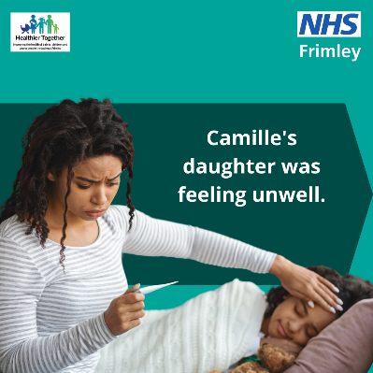 |  | 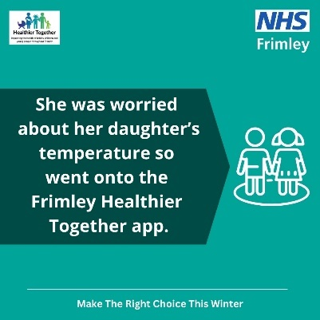 |  | 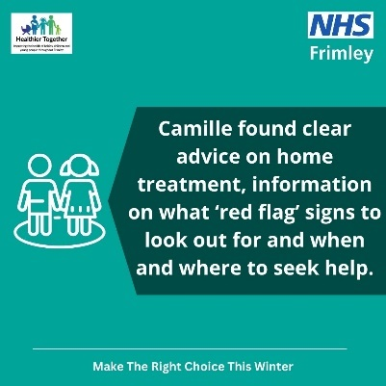
GP Access
Copy |  | Image 1 |  | Image 2 |  | Image 3
LONG: Make ordering repeat prescriptions quick and easy with the NHS App.  More people than ever before are using the NHS App to help them care for their health – are you?  With the NHS App:  - view your vaccination record  - order repeat prescriptions to your preferred pharmacy  - check symptoms and contact NHS 111  - view your NHS number  - book and manage some appointments  #MakeTheRightChoiceThisWinter  SHORT:  Make ordering repeat prescriptions quick and easy with the NHS App. More people than ever before are using the NHS App to help them care for their health – are you?  nhs.uk/nhs-app/  #MakeTheRightChoiceThisWinter |  | 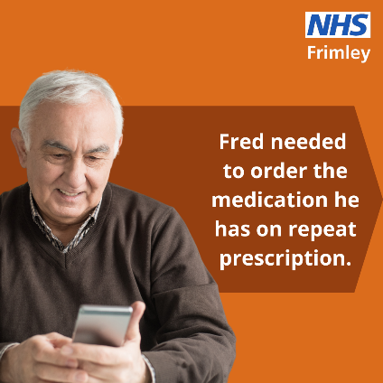 |  | 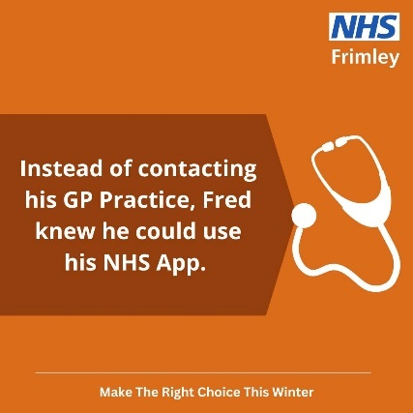 |  | 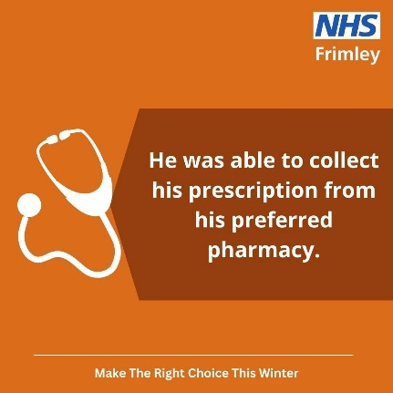

Mental Health
Copy | Image 1 |  | Image 2 |  | Image 3
LONG: Your mental health is just as important as your physical health!  Winter can affect some ongoing health conditions making connection with family and friends harder and getting outside more difficult. But there are small actions you can take to help care for your mental and physical wellbeing:  - phone a friend  - join an online activity  - get creative  - get a good night's sleep  - stay active, even if it needs to be inside  - cook a new meal  - write it down  To get more ideas about the little things that can make a big difference visit: nhs.uk/every-mind-matters/  #MakeTheRightChoiceThisWinter  SHORT: Your mental health is just as important as your physical health!  It’s the small things that can add up to make a big difference so make sure you’re doing something every day to make you feel good. For ideas visit: nhs.uk/every-mind-matters/  #MakeTheRightChoiceThisWinter | 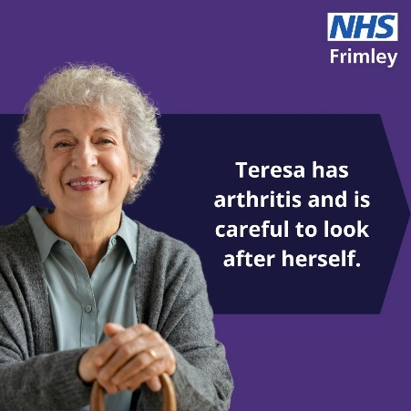 |  | 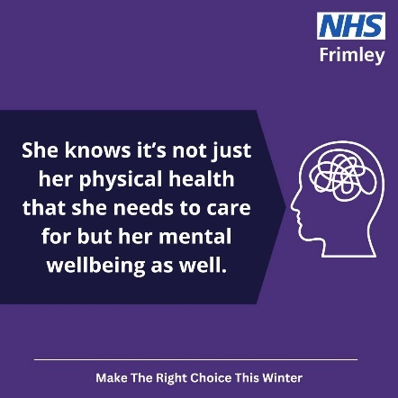 |  | 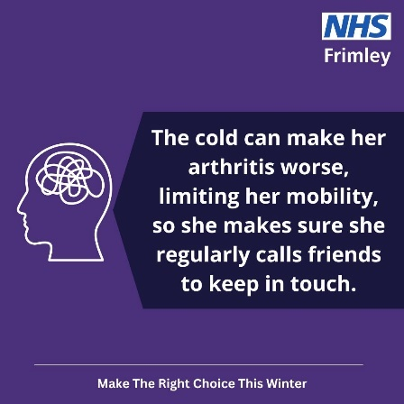
MIU
Copy |  | Image 1 |  | Image 2 | Image 3
LONG: Have you hurt yourself?  Bracknell Urgent Care Centre is open 7 days a week from 8am to 8pm.  You can attend for things such as sprains, broken limbs, cuts, grazes, scalds and burns and even x-rays which are available 8am-8pm Sunday – Friday.  Visit frimleyhealthandcare.org.uk/maketherightchoice for more information  #MakeTheRightChoiceThisWinter  SHORT: If you have a minor injury, such as sprains, broken limbs, cuts, grazes, scalds or burns, Bracknell Urgent Care Centre is open 7 days a week from 8am to 8pm.  X-rays are also available 8am-8pm Sunday – Friday.  frimleyhealthandcare.org.uk/maketherightchoice  #MakeTheRightChoiceThisWinter |  | 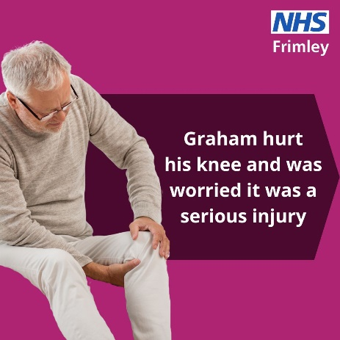 |  | 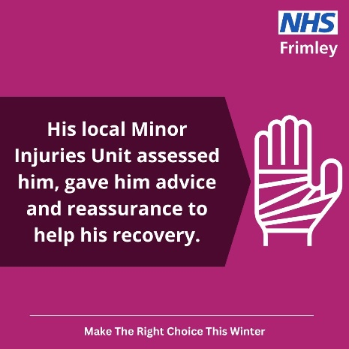 | 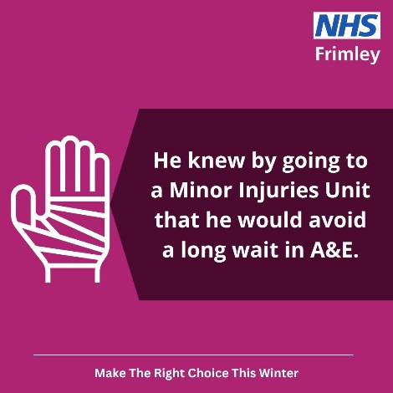

Self Care
Copy | Image
Feeling unwell?  A well-stocked medicine cabinet and plenty of rest can make all the difference when caring for yourself at home this winter.  Visit nhs.uk for further health advice if needed.  #MakeTheRightChoiceThisWinter | 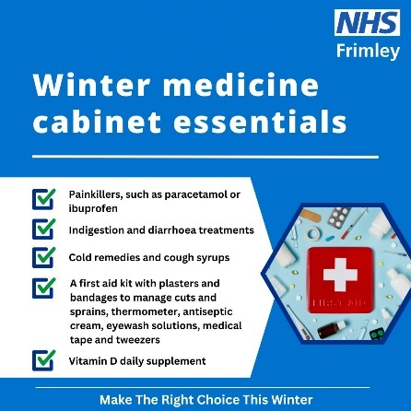
LONG: Headache, sore throat, cough, small cut or graze?  Remember that you can care for these minor issues at home with a well-stocked medicine cabinet and plenty of rest.  Visit nhs.uk for further health advice if needed.  #MakeTheRightChoiceWinter  SHORT: Care for minor issues like headaches, small cuts and grazes, sore throat or cough at home this winter with a well-stocked medicine cabinet and plenty of rest.  Visit nhs.uk for further health advice if needed.  #MakeTheRightChoiceThisWinter | 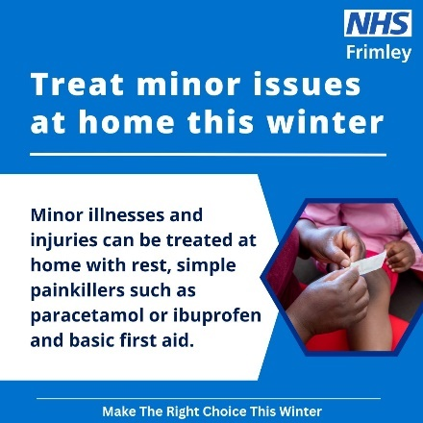
Vomiting can usually be treated at home. The most important thing is to have lots of fluids to avoid dehydration. If you need further help and advice, follow these steps.  Visit nhs.uk for further health advice.  #MakeTheRightChoiceThisWinter | 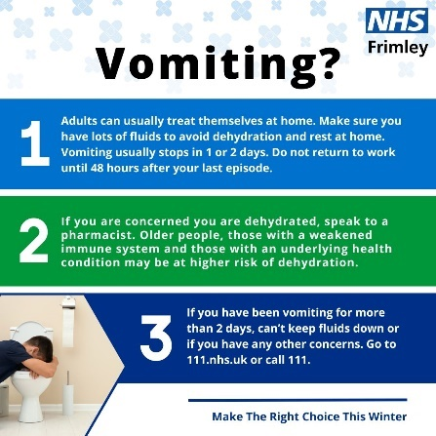
You can usually treat diarrhoea at home. The most important thing is to have lots of fluids to avoid dehydration. If you need further help and advice, follow these steps.  Visit nhs.uk for further health advice.  #MakeTheRightChoiceThisWinter | 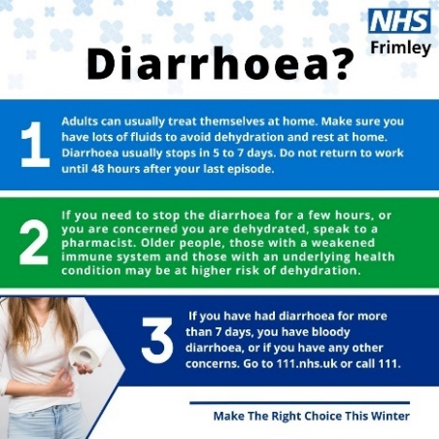
If you are struggling with a toothache, try treating it at home with painkillers. If you need further help and advice, follow these steps.  Visit nhs.uk for further health advice.  #MakeTheRightChoiceThisWinter | 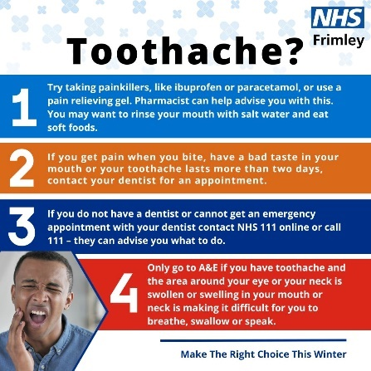
LONG: Think you have a cold? Check your symptoms at nhs.uk/conditions/common-cold  Treat your cold at home.  If you have a high temperature or you do not feel well enough to do normal activities, try to stay at home and avoid contact with others until you feel better.  Find further health advice on the nhs.uk website.  #MakeTheRightChoiceThisWinter  SHORT: Think you have a cold? Check your symptoms at nhs.uk/conditions/common-cold  Treat your cold at home.  Find further health advice on the nhs.uk website.  #MakeTheRightChoiceThisWinter | 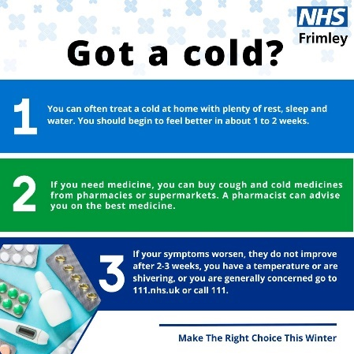

IPC
Copy | Image 1
It’s often the simplest things we do that can help keep us, our families, and those we love or care for well when viruses are circulating.  Make sure you’re doing your part to prevent the spread of infections.  #MakeTheRightChoiceThisWinter | 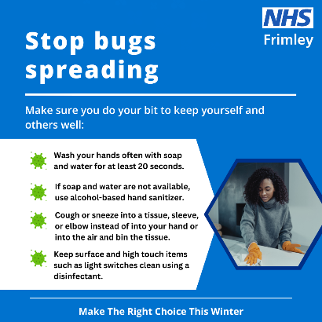
LONG: Remember one of the most effective ways to keep yourself and your family well is to regularly wash your hands.  Help teach little ones the importance of effective hand washing too and that they should always wash their hands:  * when returning home or reaching a destination  * after travelling on public transport  * before, during, and after preparing food  * before and after eating food  * before and after caring for someone at home who is sick with vomiting or diarrhoea  * after using the toilet  * after changing nappies or cleaning up a child who has used the toilet  * after blowing your nose, coughing, or sneezing  * after touching an animal, animal feed, or animal waste  Share this video to better understand how to wash your hands effectively youtube.com/watch?v=d3EPLfzNM_Q  #MakeTheRightChoiceThisWinter  SHORT: Remember one of the most effective ways to keep yourself and your family well is to regularly wash your hands. Watch and share this video to better understand how to wash your hands effectively youtube.com/watch?v=d3EPLfzNM_Q  #MakeTheRightChoiceThisWinter | 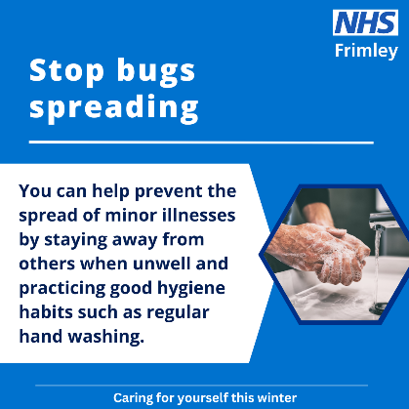

Long Term Conditions (Respiratory)
Copy | Image 1 | Image 2 | Image 3 | Image 4
LONG: People will experience the symptoms of their lung condition differently.  Learning about your condition and how it affects you personally, will help you to stay well this winter and potentially avoid a hospital stay.  If you do not have a self management plan contact your healthcare team.  Find out more about how to stay well in cold weather on the Asthma and Lung UK website asthmaandlung.org.uk/living-with/cold-weather  #MakeTheRightChoiceThisWinter  SHORT: Learning about your condition and how it affects you personally, will help you to stay well this winter and potentially avoid a hospital stay.  You can find out more about how to stay well in cold weather on the British Heart Foundation website bhf.org.uk/informationsupport/heart-matters-magazine/wellbeing/stay-healthy-winter  #MakeTheRightChoiceThisWinter | 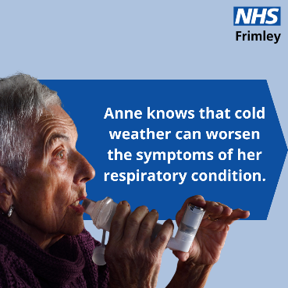 | 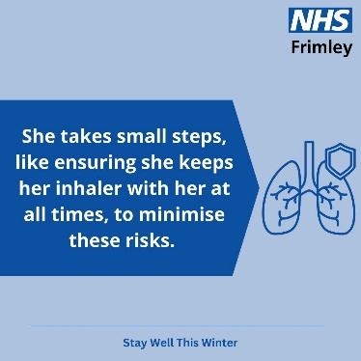 | 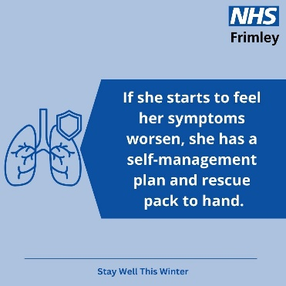 | 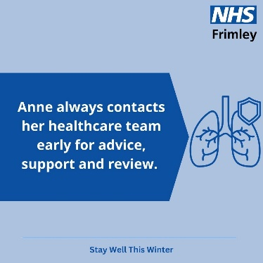
Long Term Conditions (Cardiac)
Copy | Image 1 | Image 2 | Image 3 | Image 4
LONG: Everyone living with an ongoing heart conditions will experience their symptoms differently. Learning about your condition and how it affects you personally, will help you to stay well this winter and potentially avoid a hospital stay.  Learn to recognise the signs that your condition is worsening (e.g., increased breathlessness, fatigue, pain) and have an action plan for when to contact your healthcare provider.  You can find out more about how to stay well in cold weather on the British Heart Foundation website bhf.org.uk/informationsupport/heart-matters-magazine/wellbeing/stay-healthy-winter  #MakeTheRightChoiceThisWinter  SHORT: Learning about your condition and how it affects you personally, will help you to stay well this winter and potentially avoid a hospital stay.  Find out more about how to stay well in cold weather here: bhf.org.uk/informationsupport/heart-matters-magazine/wellbeing/stay-healthy-winter  #MakeTheRightChoiceThisWinter | 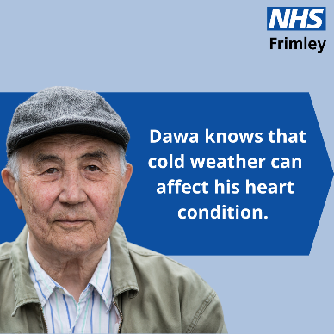 | 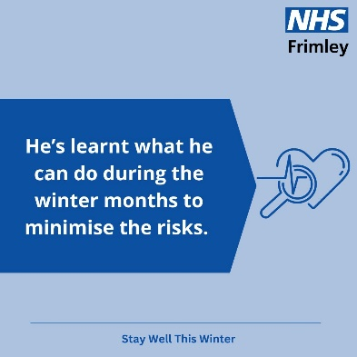 | 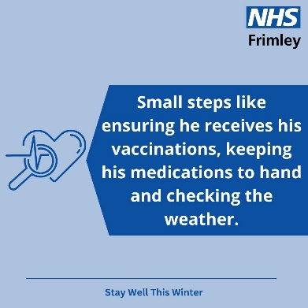 | 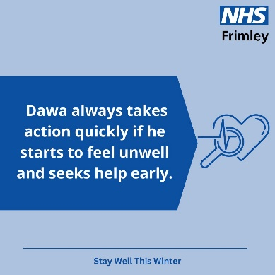
Long term conditions - Vaccinations
Copy | Image 1 | Image 2 | Image 3 | Image 4
For some, viruses such as flu and COVID-19 can be very dangerous and even life-threatening. The risk from these viruses is greater during winter when they circulate most as people spend more time indoors.  People who can get both flu and COVID-19 vaccinations ahead of this winter are:  - those aged 75 and over  - those aged 6 months and over who are immunosuppressed  - older adult care home residents  Other care home residents, those aged 65 and over, those with certain long-term conditions, people who are pregnant, those who are the main carer of an older or disabled person, or receive a carer’s allowance, household contacts of people with a weakened immune system and most children aged 2-17 can get the flu vaccine.  www.nhs.uk/vaccinations | 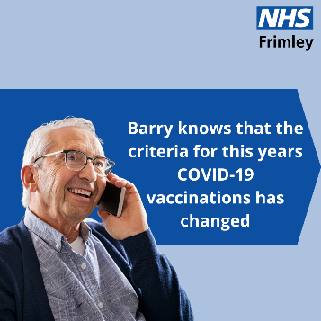 | 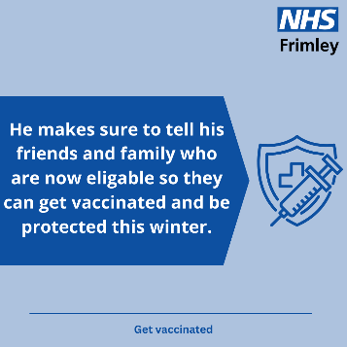 | 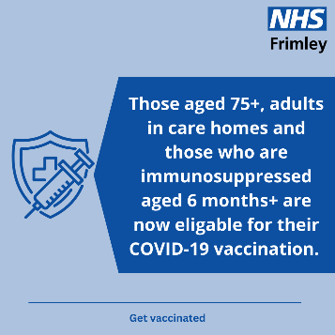
As winter approaches, it's crucial to get a flu vaccination to protect yourself and those around you. The flu vaccine reduces the risk of severe illness and helps keep our communities healthy  You can get the free NHS flu vaccine if you:  - are aged 65 or over (including those who will be 65 by 31 March 2026)  - have certain long-term health conditions  - are pregnant  - live in a care home  - are the main carer for an older or disabled person, or receive a carer's allowance  - live with someone who has a weakened immune system  www.nhs.uk/vaccinations | 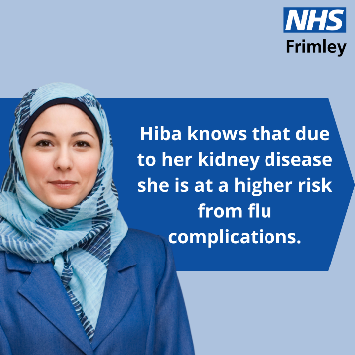 | 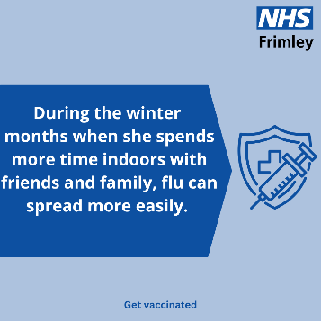 | 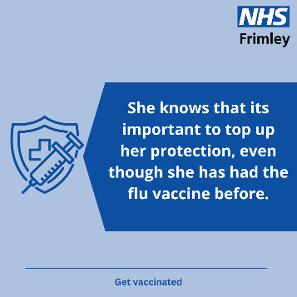
Tips
The winter months can be tough, so Frimley Health and Care have put together these top tips to help you and your loved ones stay well this winter.  #MakeTheRightChoiceThisWinter |  | 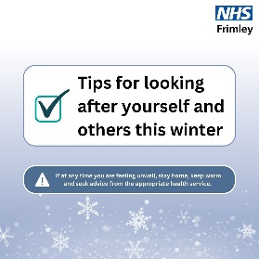 |  | 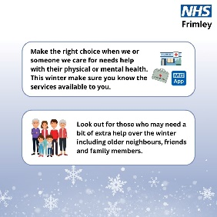 |  | 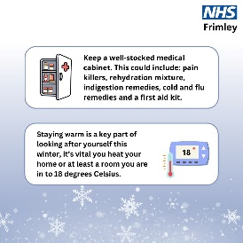 |  | 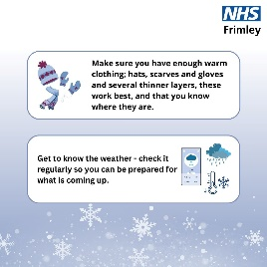
The cold weather can affect your body, especially your heart and lung health.  We have put together some tips to help you stay well this winter.  To find out more about how to look after your heart and lungs, visit the website: frimleyhealthandcare.org.uk/your-health/long-term-conditions/  #MakeTheRightChoiceThisWinter |  | 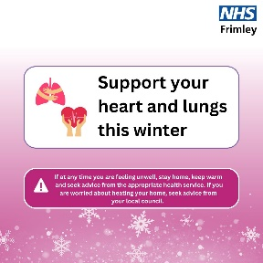 |  | 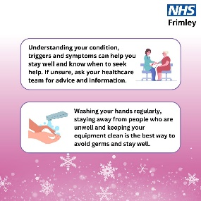 |  | 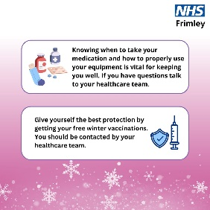 |  | 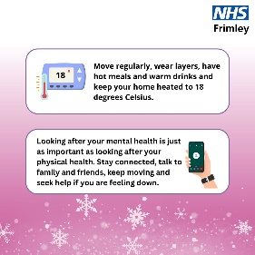 | 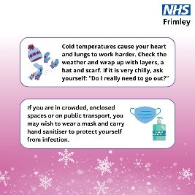
Bank holidays can disrupt your health care routine, so it’s important to know when they are and to be prepared.  We have put together some tips to help you get organised before and during a bank holiday.  #MakeTheRightChoiceThisWinter |  | 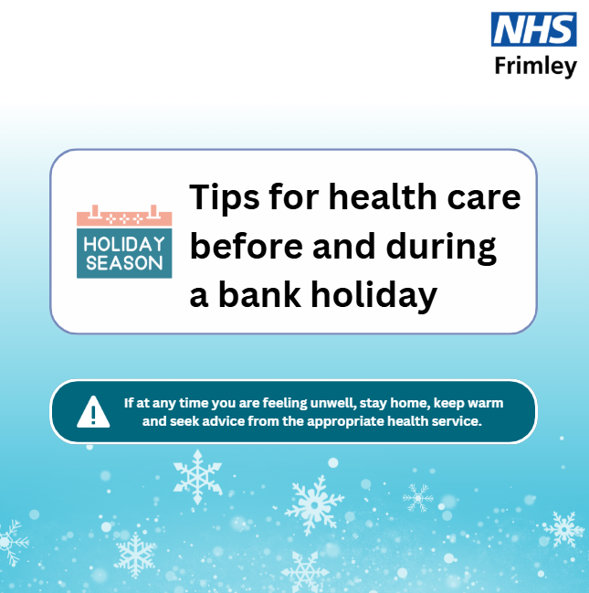 |  | 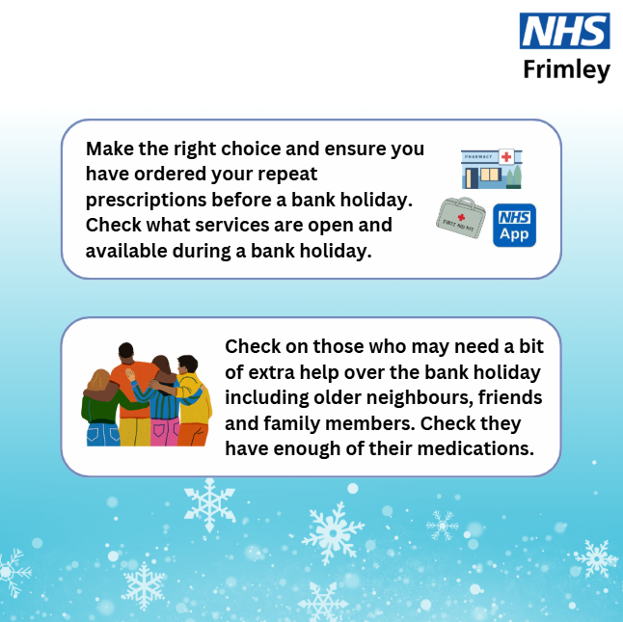 |  | 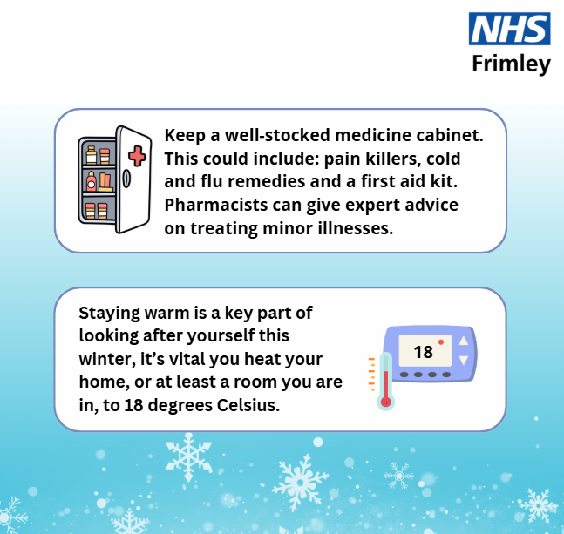 |  | 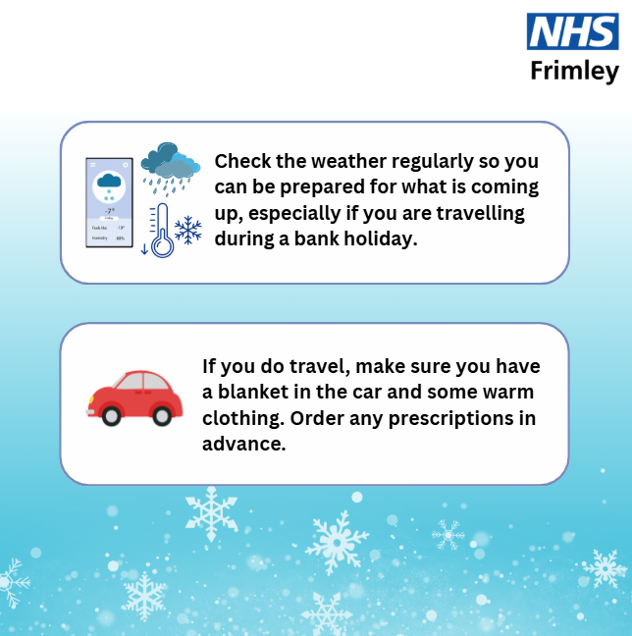
It can be extremely stressful when your child is unwell.  We know that there is a huge amount of information available at your fingertips, so Frimley Healthier together has put together some top tips to help you care for your children.  Find more information on Frimley Healthier Together, download the app today or visit https://frimley-healthiertogether.nhs.uk  #MakeTheRightChoiceThisWinter |  | 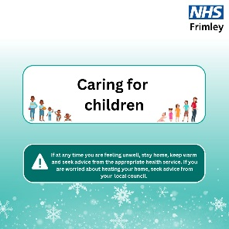 |  | 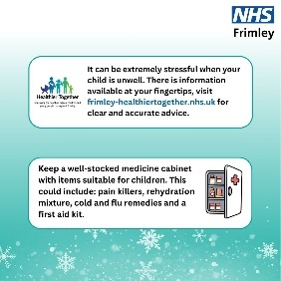 |  | 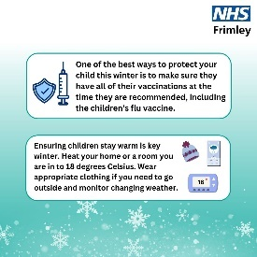 |  | 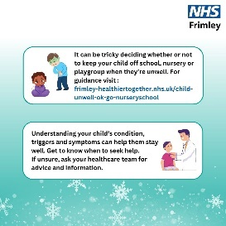
The winter months can be tough, so Frimley Health and Care have put together these top tips to support your mental wellbeing this winter.  #MakeTheRightChoiceThisWinter |  | 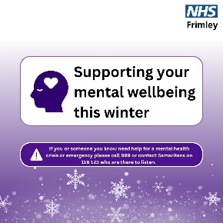 |  | 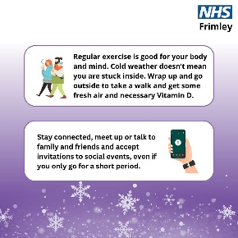 |  | 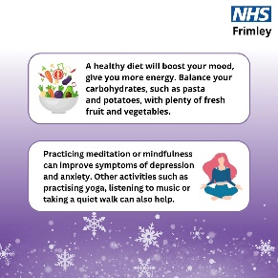 |  | 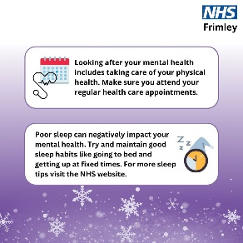
Get winter ready. Frimley Health and Care have put together some helpful tips on ways that you and your loved ones can stay well this winter.  #MakeTheRightChoiceThisWinter |  | 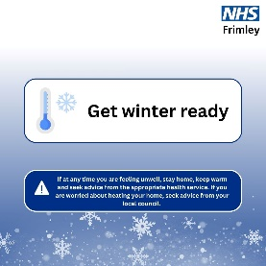 |  | 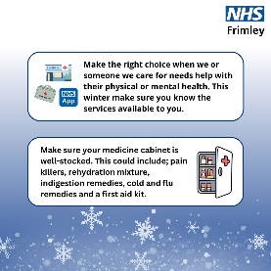 |  | 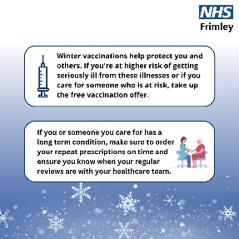 |  | 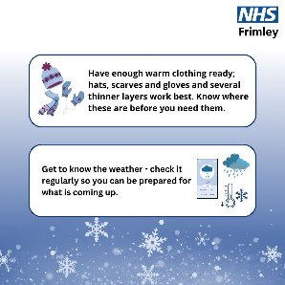
Stories
 | 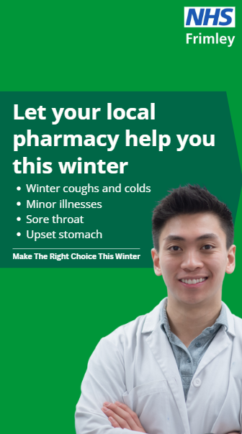 | 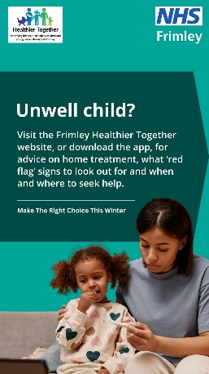 | 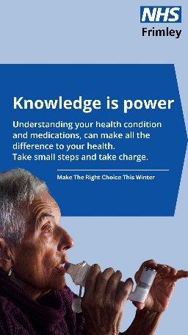 |  | 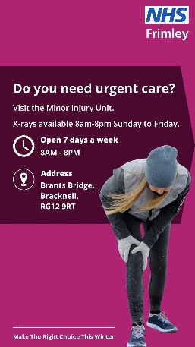 |  | 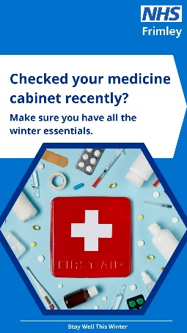 | 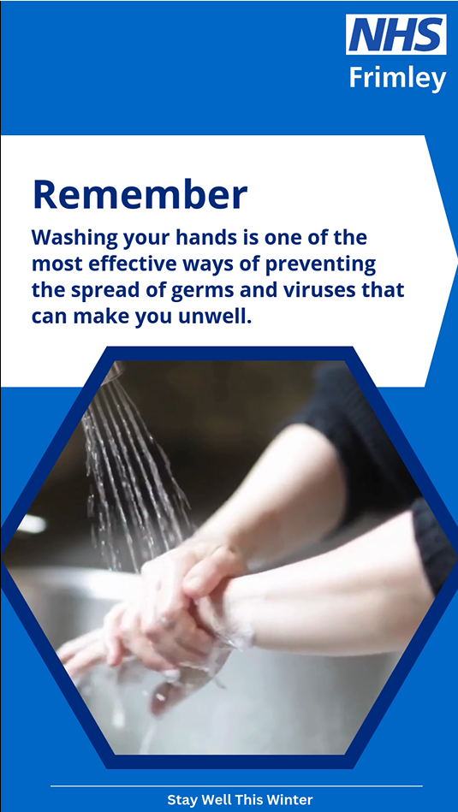 | 